Altitude is a line drawn from the vertex of a triangle and makes a 90 degree with the base and cut it in two segments
Three similar triangles can be formed
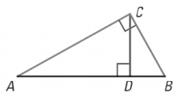

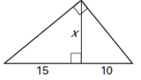
Geometric Mean

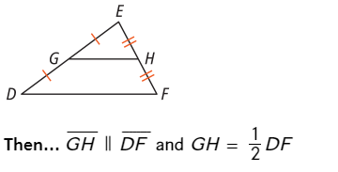  Midsegment | Angle Bisector  