**Directions for Envision Assignment # 3**

**\*\*\*\*Go through the notes attached then Go to Envision**

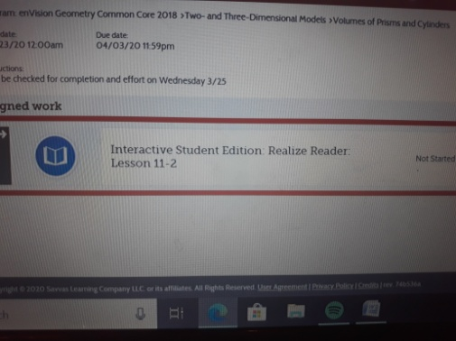

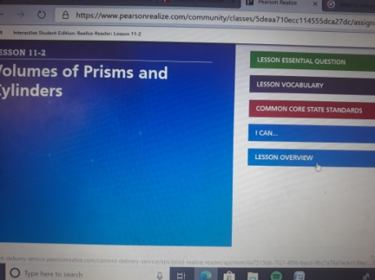**1-Click on assignment**

**2- Click on Lesson Overview**

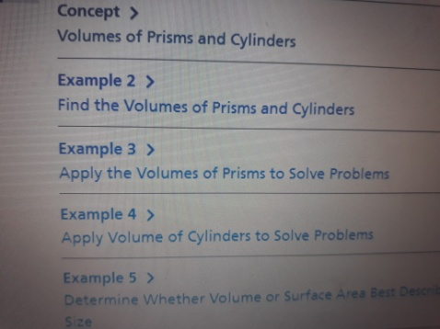

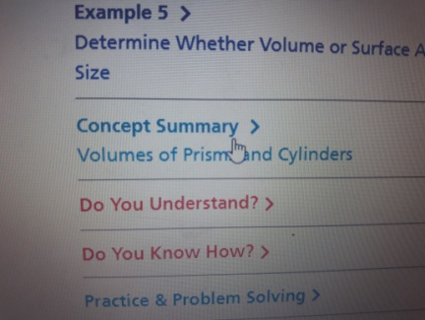

**3-Go through examples 2,3,4**

**4- Read Concept Summary**

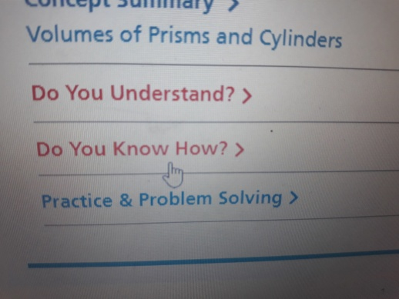

**5- Do #6-12 under DO YOU KNOW HOW?**

**\*\*\*\*This Assignment will be checked in for completion and effort on Wednesday 3/25/2020**