**Directions for Envision Assignment # 4**

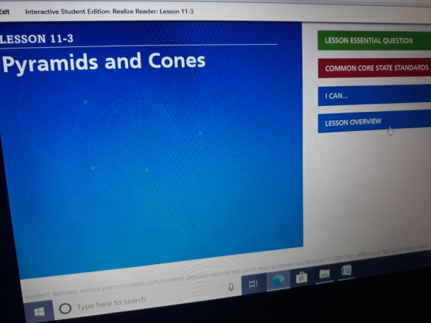**\*\*\*\*Go through the notes attached then Go to Envision**

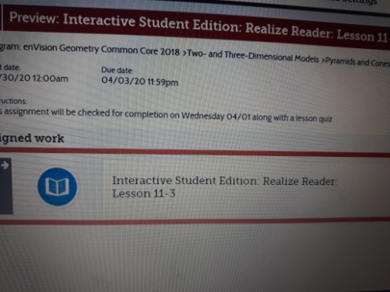

**1-Click on assignment**

**2- Click on Lesson Overview**

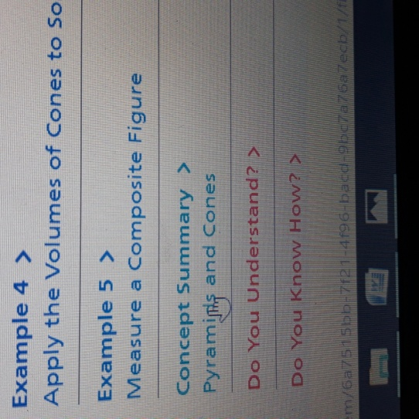

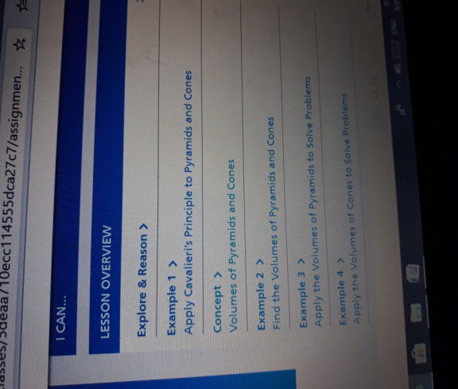

**3-Go through examples 1,2,3,4**

**4- Read Concept Summary**

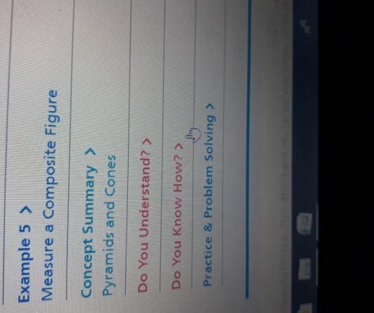

**5- Do #5-9 under DO YOU KNOW HOW?**

<https://www.youtube.com/watch?v=_Eaur5e2oDY>