**Unit 3 Review Name:_____________**

**Test Thursday October 10,2019**

1- Write a description of the rule .

**(a)** translation 10 units to the right and 8 units up

**(b)** translation 10 units to the left and 8 units down

**(c)** translation 10 units to the right and 8 units down

**(d)** translation 10 units to the left and 8 units up

2- Point *A* (–2, –10) is reflected over the *x*-axis. Write the coordinates of *A’*.

**(a)**  **(c)** 

**(b)**  **(d)** 

**3-** Point *D* (2, 4) is rotated 180° about the origin, what is the coordinate of *D’*?

**(a)**  **(c)** 

**(b)**  **(d)** 

4- If this pentagon is reflected across y=-x

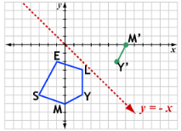

What would the coordinate for point L’

|  |
| --- |
| 5- The coordinates of the vertices of triangle 1 are A(6,6), B(12,9), C(9,6).  The coordinates of the vertices of triangle 2 are A′(-6,-6), B′(-12,-9), C′(-9,-6).  What transformation was performed on triangle 1 to create triangle 2?  a- Translation b-Reflection across the y-axis  c- Reflection across y=x d- Rotation 180 degree |

6-



***A***

***C***

***B***

***A′***

***B′***

***C′***

1. Describe the types of transformations the triangle ABC

Undergoes

b- Are the above two triangles congruent? Explain your reasoning

7-

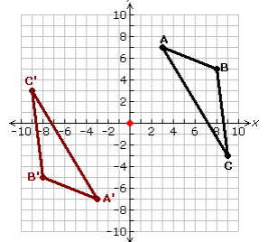a- What type of this transformation does the given picture represent? Explain your reasoning.

1. Describe the transformation that you chose based on the picture

8- A recycling logo is shown. Describe all the transformations that map this logo onto itself.

9- Apply the transformation  to the rhombus below. What single vector maps the pre-image onto the image?



|  |  |  |  |
| --- | --- | --- | --- |
| A. | The vector is . | C. | The vector is . |
| B. | The vector is . | D. | The vector is . |

10 . Quadrilateral RAPS is located at the vertices R(-4,1), A(-3,4), P(0,5), S(-1,1). Where will points , be located after the quadrilateral has been reflected across the line *y* = *x* and then rotated 180º about the origin?

|  |  |  |  |
| --- | --- | --- | --- |
| A. |  | C. |  |
| B. |  | D. |  |

11. What dilation maps triangle ABC onto triangle A’B’C’ below?



|  |  |  |  |
| --- | --- | --- | --- |
| A. |  | C. |  |
| B. |  | D. |  |

1. 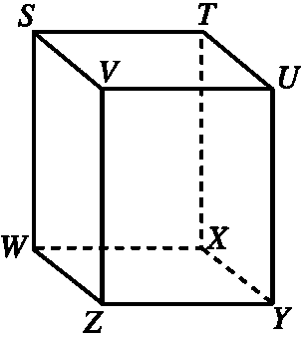Which set of four points are not coplanar?
2. S,W, X, and U c. S, T, V, and U
3. W, V, X, and Y d. T, U, X, and Y

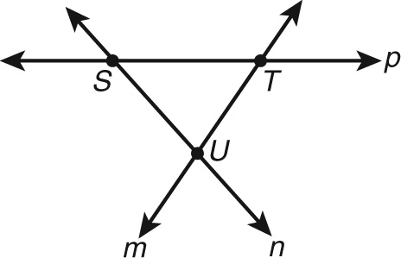

2- Name all the rays that has an endpoint U

 3- How many line segments does this picture have?

