**Name:_________________ Practice Monday 10/21/19**

**I- Angle Bisector**

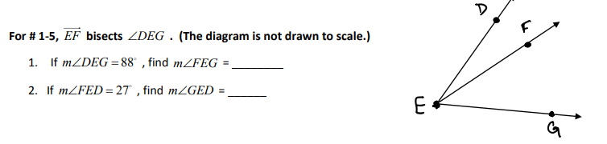 If

**Complete the below statements:**

a- m<1=________

b- <1 __________

c- <DEG ___________

d- m< MEF=_________

**II. Vertical Angles**

Name the two pair of vertical angles.

1.___________________

2.___________________

Find the value of x in degrees in each diagram below. Show your thinking.

3x + 3

105

x

108

