**Unit 2 Review Questions Name:_______________**

1. If the reflection of point A across line m is the point A’, then line m is the ____________________of AA’

Where A is the __________________and A’ is the _________________

1. The composition of two reflections across parallel line is a ___________________
2. The composition of two reflections across intersecting line is a ___________________
3. What is a perpendicular bisector?
4. What is rigid transformation?
5. What is the difference between a pre-image and an image and how do we label them?
6. What is rotation? What are the main parts involved in rotating an image?
7. Define translation and reflection
8. Which of the following transformations does not result in a congruent figure?

(a) dilation (c) reflection

(b) rotation (d) translation

10 -The pre-image and image of what transformation is congruent?

|  |  |  |  |
| --- | --- | --- | --- |
| A. | Reflection and dilation | C. | dilation |
| B. | Translation, Reflection, and Rotation | D. | rotation |

11-Which represents a translation of the figure?

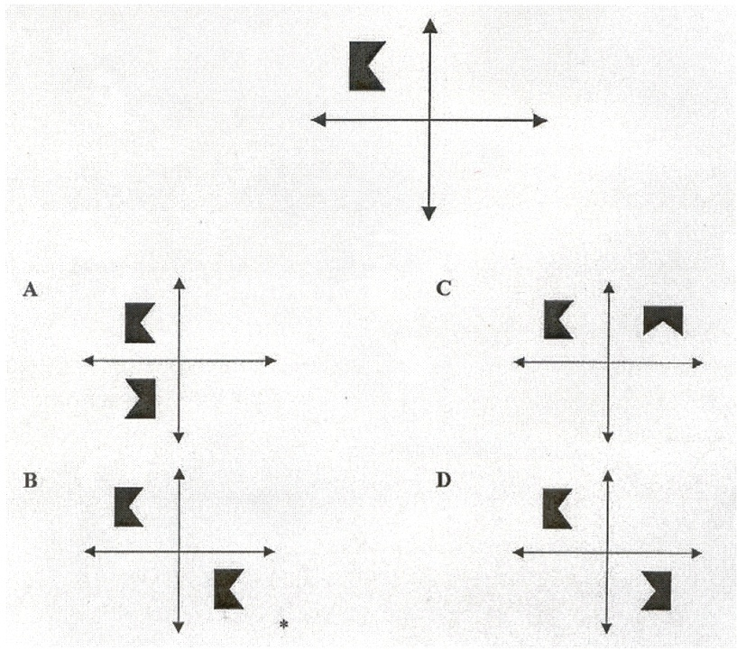

12- For each one of the polygons below, find how many lines of symmetry to they have and the angle of rotation 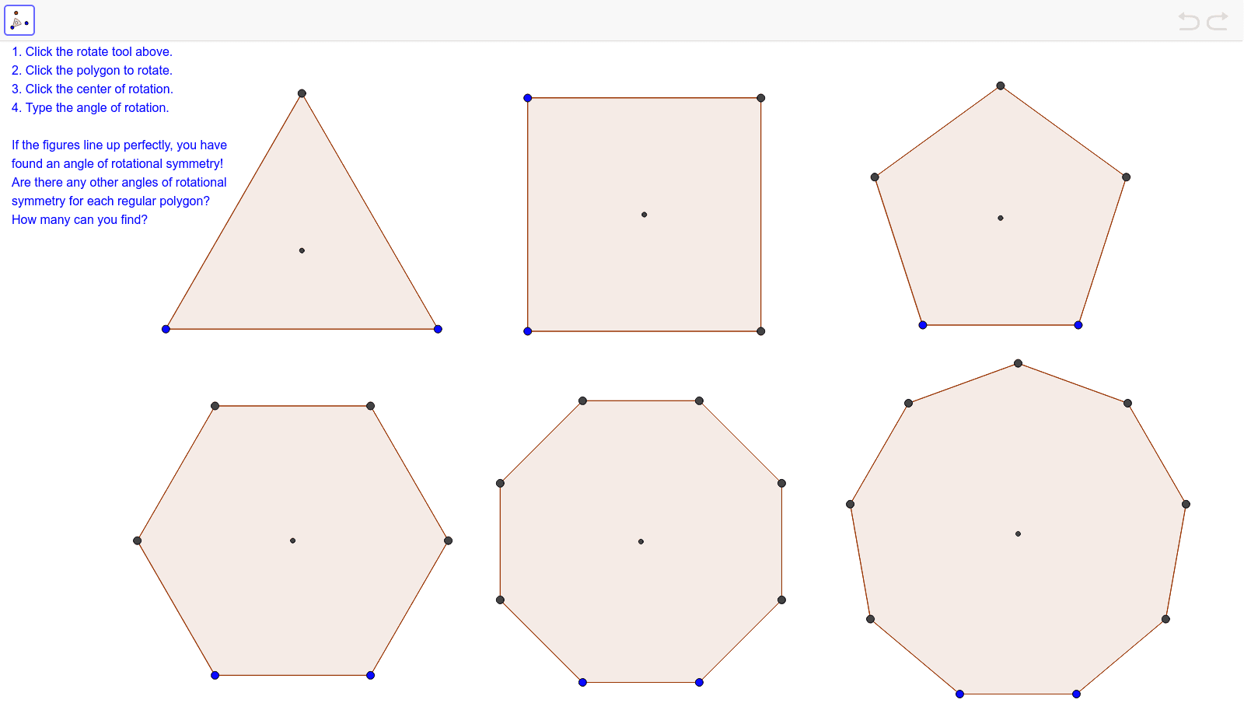

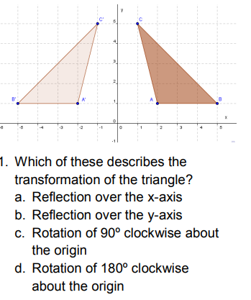

13-

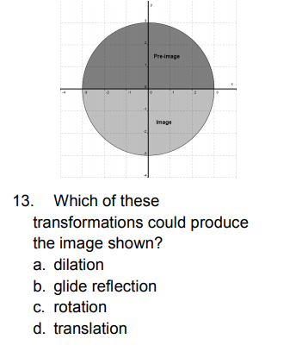14-

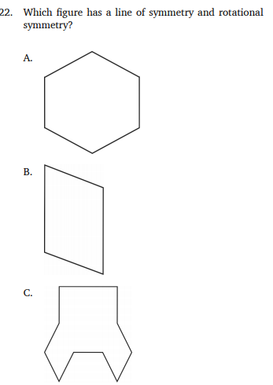

15-