Monday  05/06/2019 | What do I need to work on? | Tuesday:  05/07/2019
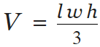  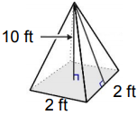  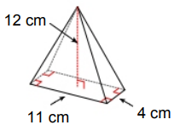 |  | 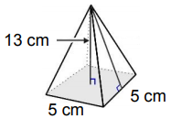  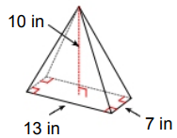
Date:  05/08/2019 | Date:  05/09/2019 | Date:  05/10/2019
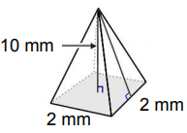  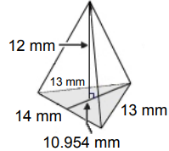 | 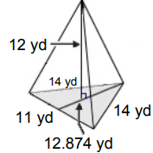  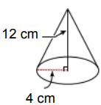 | Find the length of a triangular prism with a volume of 227.5 ft³, height of 13ft, and width of 7 ft.  Find the width of a rectangular pyramid with volume 112 cm³, length of 6cm, and height of 8cm.

