Bell work week of 4-15-2019 Name:__________________________________________

Monday | Tuesday
2m  3m  4m  Volume of a Prism  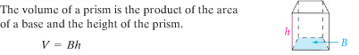  B = the area of the base  h = height of prism (the height is the segment that connects two Bases)  Find the volume for the given rectangular prism.  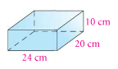  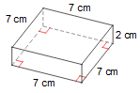 | Find the volume for the given triangular prism.  Remember V=Bh /B=Area of a triangle  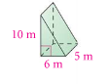

Wednesday | Thursday
1m  5m  3m  2m  Find the volume for the given cylindrical prism.  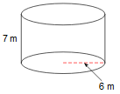  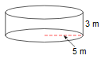 | 