1. Use the diagram to:

Name a pair of vertical angles: ____ & ____

Name a pair of Supplementary angles ____&_____

< EBD and <FBE are ___________

<FBA and <ABC are ___________

Give an example of a linear pair: _______________________

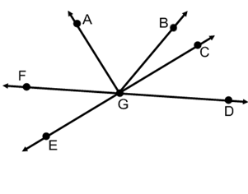

1. 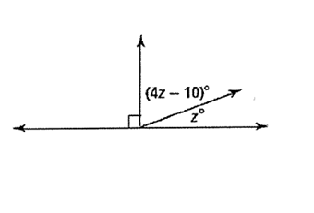

Find x

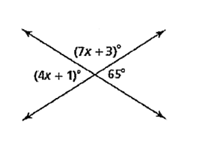 **Solve for x**