Identify each pair of angles as adjacent, vertical, complementary, supplementary, or a
linear pair.
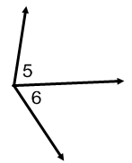
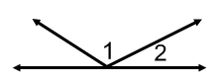
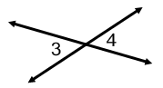
1. 2. 3.

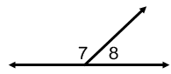
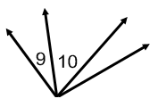
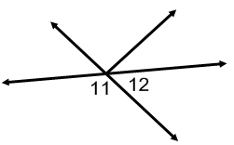
4. 5. 6.

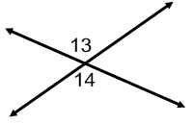
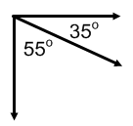
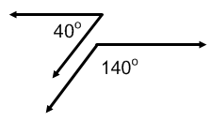
7. 8. 9.

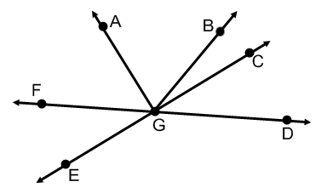
Use the figure at the right to answer each question.
- Name two acute vertical angles.
- Name two obtuse vertical angles.
- Name a pair of adjacent angles
- Name a linear pair.
- Name a pair of complementary angles.
- Name an angle supplementary to $∠\text{FGE}$

For #1-6, use the figure at the right.
- Name two acute vertical angles.

- Name two obtuse vertical angles.

- Name a linear pair.

- Name two acute adjacent angles.

- Name an angle complementary to .

- Name an angle supplementary to .

Find the measure of each numbered angle.
7. 8. 9.

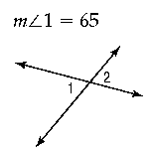
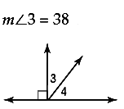
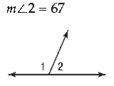
10. 11. 12.

13. 14. 15.

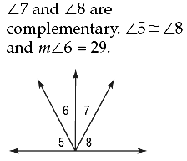
16. 17. 18.

