**Unit 2 - Practice Test Name: _______________________________ Date: _______**

**I can use appropriate vocabulary/notation: ____________**

1. 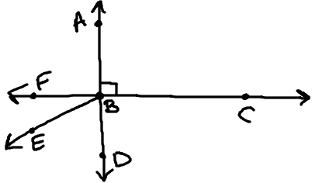Use the diagram to the right to:
   1. Name a pair of supplementary angles: ____________ & ____________
   2. < EBD and <FBE are ______________________
   3. Give an example of vertical angles: _______________________

**I can use properties of angles to determine measures: ____________**

1. State the relationship between the angles to justify your equation and then solve for x and y using properties of angles.

3y + 2

5y - 6

6x - 1

1. State the relationship between the angles to justify your equation and then solve for x.

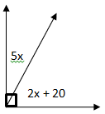

4.) If a // b and c // d, prove that < 4 $≅$ < 10 . **Justify every equation that you used.**

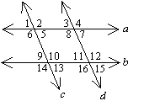

5y + 23

12x - 48

1. Find the value of the variable if  m < 1 = 7x – 12 and m < 5 = 5x + 6. **Justify the equations**.



6.) Solve for x and y. Justify each step.

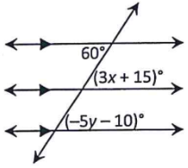

7.) Identify 2 Consecutive Interior Angles.

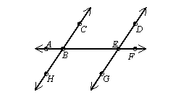

8.) Identify 2 sets of Corresponding Angles.

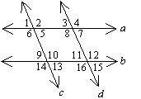

9.) Line *r* is parallel to line *t*. Determine the *m*4 and the correct justification:



1

127°

10.) Lines a, b, c and d are shown below and a // b. Name all angles that are supplementary to <x.



x

167°

11.) The midpoint of segment RQ is (-1, 0), point R is located at (-3, 4) the coordinates of endpoint Q are:

a) (-5, 8)

b) (-4, 1)

c) (1, 2)

d) (1, -4)

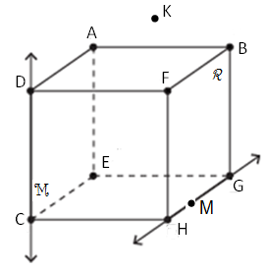

Z

Use the above figure to answer the following questions.

12.) Name for plane M in two different ways (left side of the box)

13.) Identify a pair of opposite rays.

14.) Where is the intersection of $\overset{⃡}{DZ}$ and $\overline{EC}$?

15.) Name 3 collinear points.