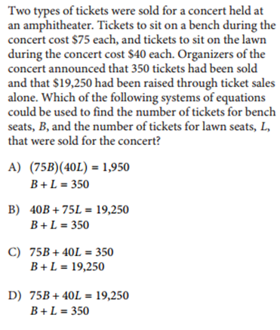
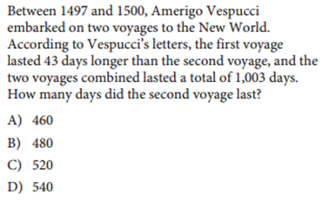
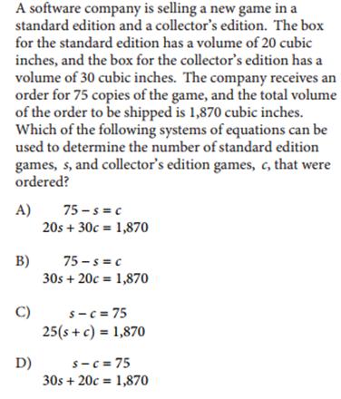
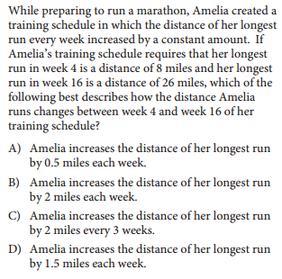

One of the requirements for becoming a court reporter is the ability to type 225 words per minute. Ali can currently type180 words per minute, and believes that with practice he can increase his typing speed by 5 words per minute each month. Which of the following represents the number of words per minute that Ali believes he will be able to type m months from now?
A) 5+180 m
B) 225+5 m
C) 180+5 m
D) 180−5 m

The monthly membership fee for an online television and movie service is$9.80. The cost of viewing television shows online is included in the membership fee, but there is an additional fee
of $1.50 to rent each movie online. For one month, Jill’s membership and movie rental fees were $12.80. How many movies did Jill rent online that month?
A) 1
B) 2
C) 3
D) 4
Salim wants to purchase tickets from a vendor to watch a tennis match. The vendor charges a one-time service fee for processing the purchase of the tickets. The equation Tn = 15 +1 represents the total amount T,in dollars, Salim will pay for n tickets. What does 12 represent in the equation?
A) The price of one ticket, in dollars
B) The amount of the service fee, in dollars
C) The total amount, in dollars, Salim will pay for one ticket
D) The total amount, in dollars

A gardener buys two kinds of fertilizer. Fertilizer A contains 60%filler materials by weight and Fertilizer B contains 40% filler materials by weight. Together, the fertilizers bought by the gardener contain a total of 240 pounds of filler materials. Which equation models this relationship , where x is the number of pounds of Fertilizer A and y is the number of pounds of Fertilizer B?
A) 0.4 x +0.6 y = 240
B) 0.6 x +0.4 y = 240
C) 40 x +60 y = 240
D) 60x+40 y =240

X + Y = 75
The equation above relates the number of minutes, x, Maria spends running each day and the number of minutes, y, she spends biking each day. In the equation, what does the number 75 represent?
A) The number of minutes spent running each day
B) The number of minutes spent biking each day
C) The total number of minutes spent running and biking each day
D) The number of minutes spent biking for each minute spent running

y = 19.99 + 1.50 x
The equation above models the total cost y, in dollars, that accompany charges a customer to rent a truck for one day and drive the truck x miles. The total cost consists of a flat fee plus a charge per mile driven. When the equation is graphed in the xy-plane, what does the y-intercept of the graph represent in terms of the model?
A) A flat fee of $19.99
B) A charge per mile of$1.50
C) A charge per mile of $19.99
D) Total daily charges of $21.49

