Finding Angle Measures Name:______________________________ Hour:________

For each diagram, find the value of the variable and the measure of each angle. Be sure to state the relationship between the angles to justify setting up your equation.

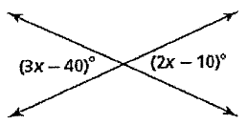 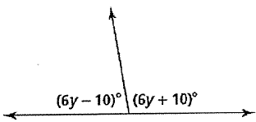

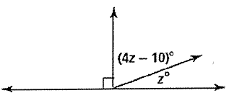 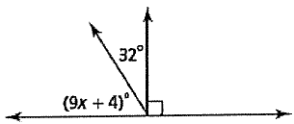

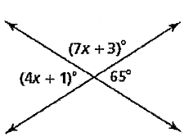 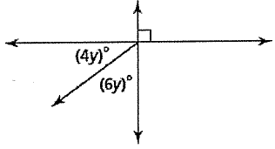



Be sure to state *all 5 relationships* and solve for all 5 variables!