Even, Odd, or Neither Worksheet Name: _______________________

Determine whether the following functions are even, odd, or neither.

1. f(x) = 4x – 3  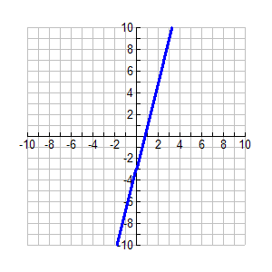 | 2. f(x) =$\left|x\right|+1$  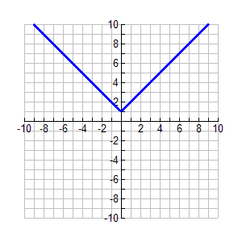 | 3. f(x) = -x² – 4  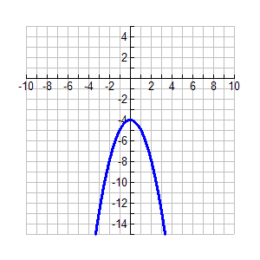
4. f(x) = $\frac{1}{3}$x³  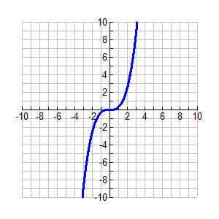 | 5. f(x) = 7x  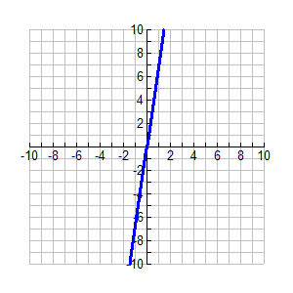 | 6. f(x) = $\sqrt{x+5}$  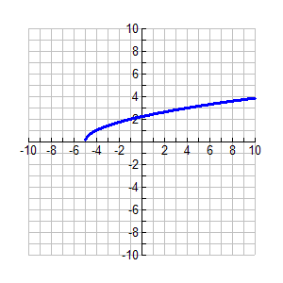

Determine algebraically whether the following functions are even, odd, or neither.

7. f(x) = 3x² 8. f(x) = x³ – 2 9. f(x) = 3x + 4

10. f(x) = x² – 5 11. f(x) = 10x + 5 12. f(x) = 2(x+1)³

