Backyard Scavenger Hunt

Look for these things in your backyard. Check the box next to the item when you find it. When you find everything, answer the questions on the next page.
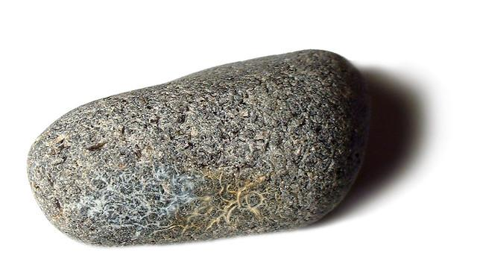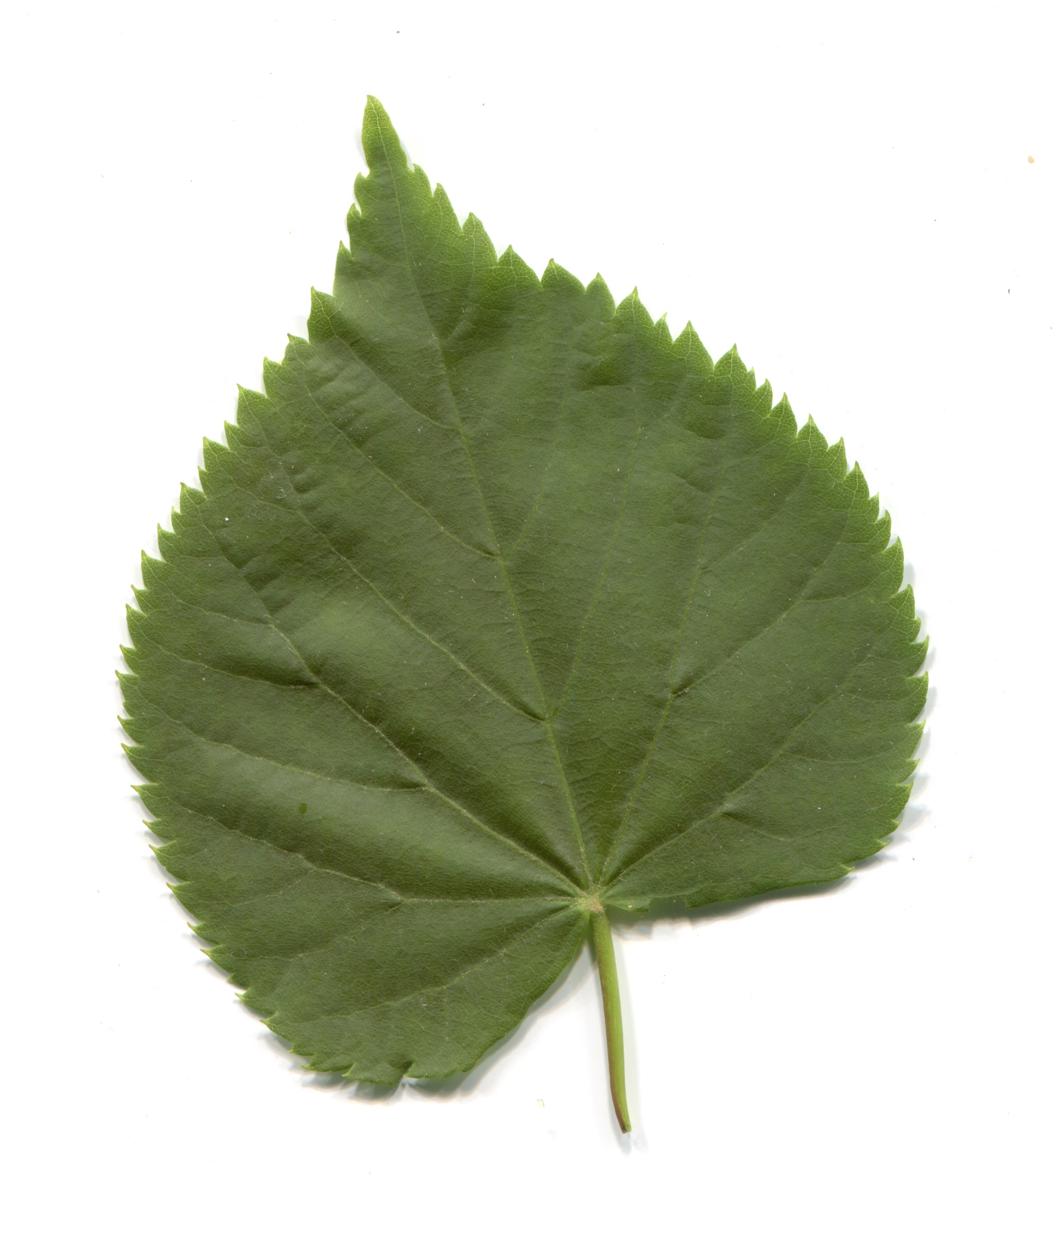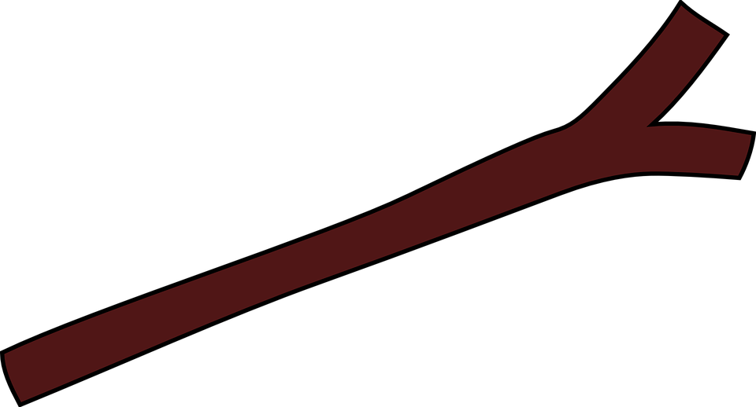
▢ Rock ▢ Leaf ▢ Stick

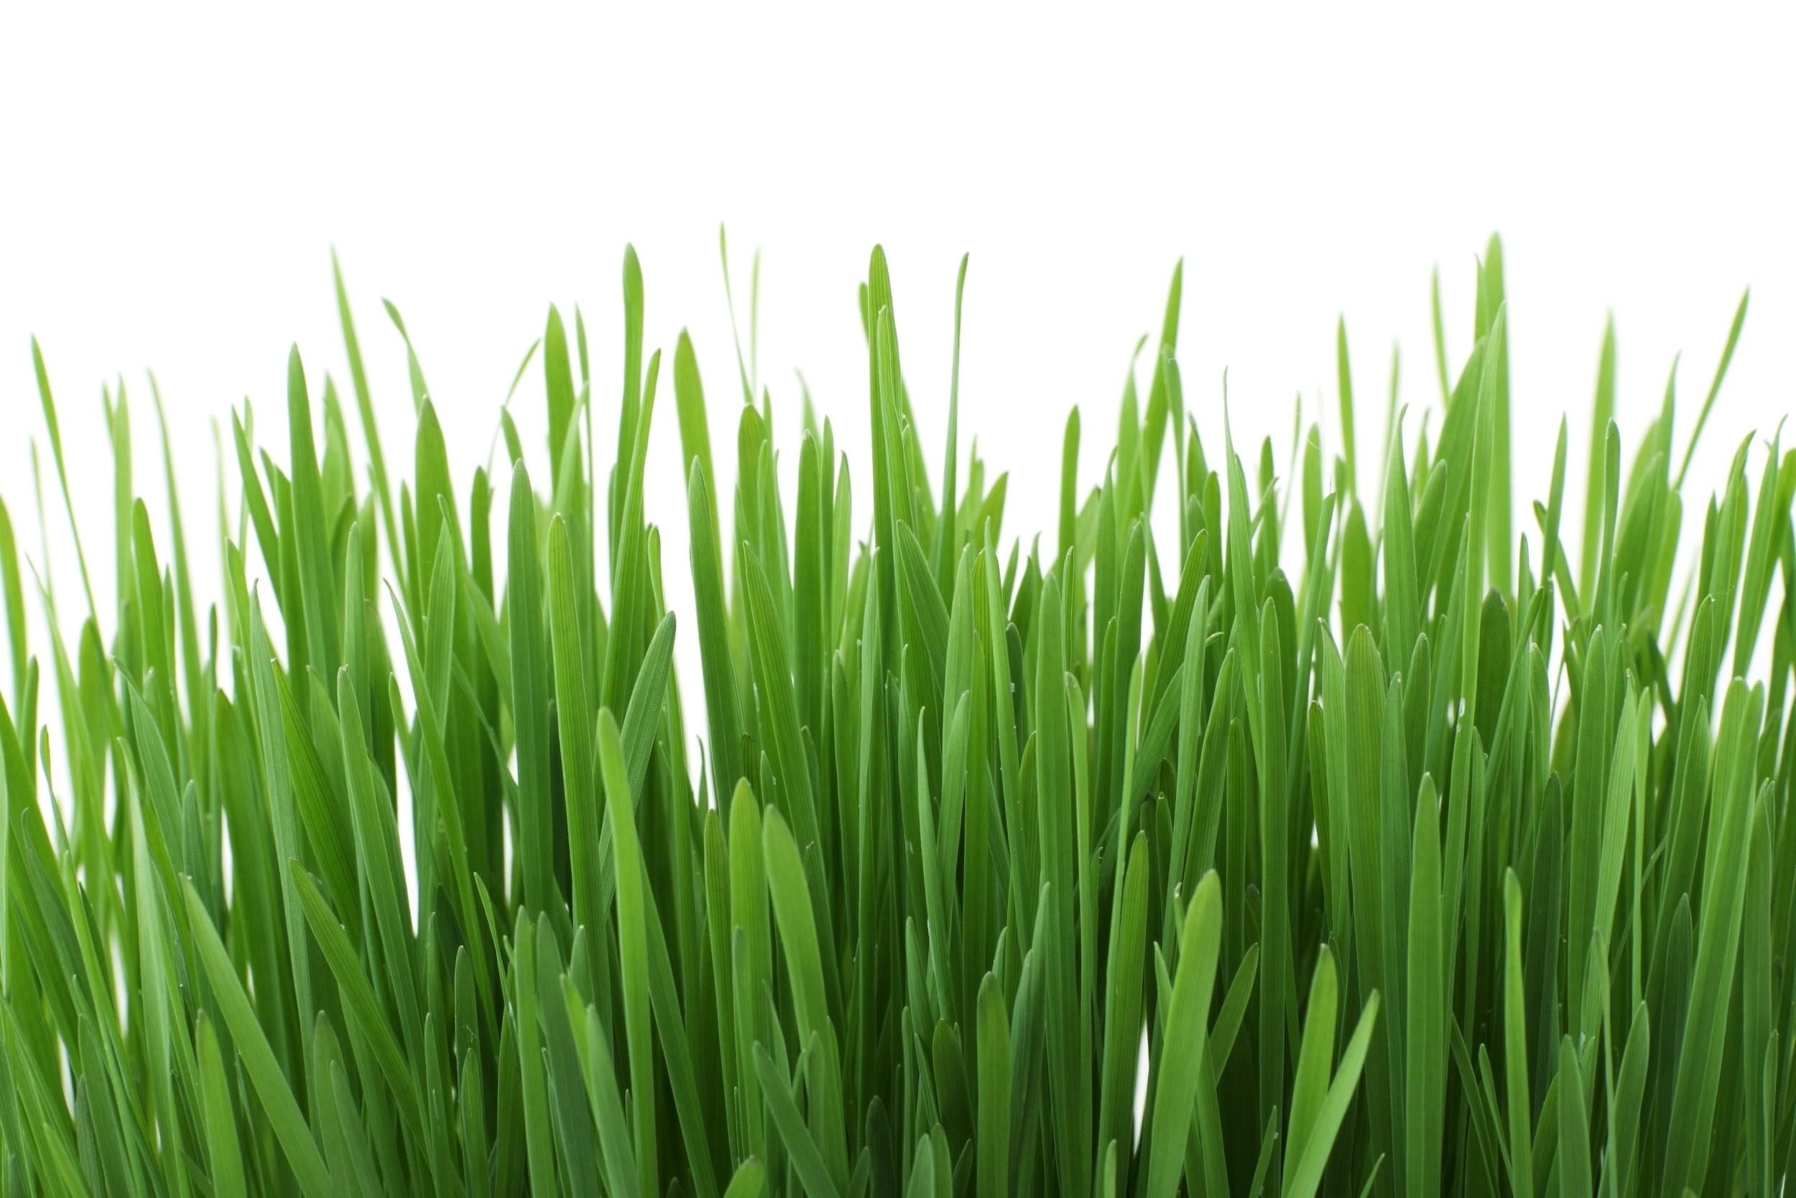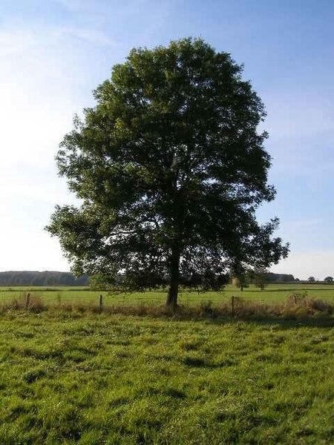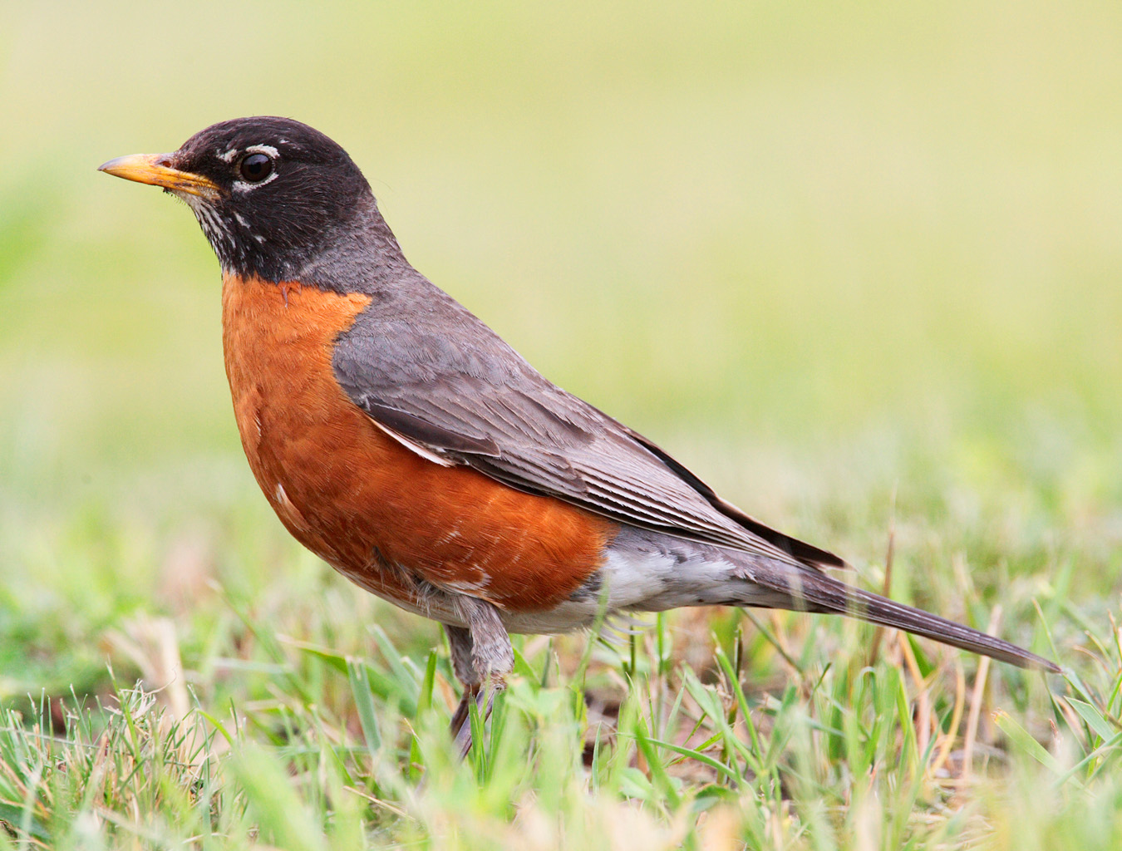
▢ Grass ▢ Tree ▢ Bird
- What was the easiest thing to find?

- What was the hardest thing to find?

- Choose one thing that you found and use your senses to describe it. How did it feel, look, smell, sound?

- What are some different things that you might find in your backyard during the spring and summer?

