**Code of Hammurabi**

**Project**

**Part I:**

1. Read the Code of Hammurabi-Overview sheet *(check blog),* and sections 4-5 in chapter 6 in the textbook that explains the background information about King Hammurabi of the Babylonian Empire and his code of laws.
2. Read the *actual laws* that Hammurabi created to keep and sustain order in his society *(check blog)*
3. ***Create a poster*** including everything under Part II

**Part II:**

*On a small poster (try to use same size posters we have in class, about 12x18in.), include the following:*

1. ***Write a short summary*** explaining the Code of Hammurabi (1 paragraph 6-7 sentences). Consider these questions: Who created it? Why was it created? Who were the laws for? Use the information provided on the blog (what we read in class), the textbook, and any other resources you can find. Must be in your own words, *no copying*!
2. ***Write a short summary*** about *your feelings* of the laws. Why would Hammurabi make these laws? Do you feel they were too extreme? Why or why not? Do you feel they were effective? Would these laws be able to exist in today’s world? Explain your reasons (1 P, 5-6 sentences).
3. If you were a leader of a school (principal), what would your code of laws be? ***Create a list of 10 laws*** that clearly describe a situation where a rule was broken, and the punishment given.
4. Please keep punishments *clean, and school friendly!!!* (no deaths, or physical harm)  
   Remember that Hammurabi had different punishments for different people. He had specific laws for men, women, slaves, scholars, farmers, artisans, etc…
5. ***Draw a picture*** that would go on top of your own code of law stele. Label what is in the picture, and explain what the picture means. Color it!!

**Layout, style, and organization of poster is entirely up to you! If you want full credit, then everything must be included!!

**Need a TITLE, and each section on the poster must have a *heading!!!*

**Due Date:** December 15th, 2014

5 points off each day late

NOTHING will be accepted after December17th

**Total Points Possible:** 45 points summative

**Code of Hammurabi Project Rubric**

Student Name:

/10 pts Summary, in your own words, about the Code of

Hammurabi – 1 paragraph, 6-7 sentences - *Heading*

/10 pts Summary on YOUR feelings of Hammurabi’s code of

laws – 1 paragraph, 5-6 sentences - *Heading*

/10 pts List of your 10 laws if you were principal - *Heading*

/10 pts Drawing – labeled, explanation and colored - *Heading*

/5 pts Title, followed directions, poster neatly organized

/45 pts TOTAL SCORE

PLEASE ATTACH THIS SHEET, RUBRIC SIDE OUT, ON THE BACK OF THE POSTER!

You can glue, tape, staple, etc…, as long as this sheet is on the back!

**Code of Hammurabi - Overview**

In about 1780 B.C.E, a Babylonian ruler named Hammurabi created hundreds of laws and had them written on an eight-foot stele made of black basalt. Now in the Louvre Museum in Paris, the stele's inscriptions were unintelligible for thousands of years.

Who was Hammurabi? What language did he speak? Since people at that time did not have paper, how did they write?

The **Babylonians** were a group of people who lived in an area called Mesopotamia, which is now called Iraq. The Babylonians were part of a larger group called the **Semites**, who all spoke the same language. **Hammurabi** united all of the Semites and established a capital in Babylonian territory. With all of Mesopotamia united, Hammurabi established a code of law to be used throughout his kingdom. The code became known as the **Code of Hammurabi**, and is one of the oldest, as well as best preserved, recorded laws in history. The Code of Hammurabi provided laws and punishments that were applicable to citizens based on their social status and gender.

Using a stylus, writers inscribed words on wet clay. Since their writing looks like wedges to us, we call it cuneiform (based on cuneus, the Latin word for wedge).

When these clay tablets were found during modern times, no one initially understood their meaning. Although Egyptian hieroglyphics had been deciphered (because Jean Francois Champollion understood two of the three languages inscribed on the Rosetta stone), nothing similar had been located to help decode cuneiform writing. Not, that is, until Henry Rawlinson scaled the face of a cliff in the Zagros Mountains of Western Iran, where an inscription was written over the tomb of King Darius I.

After a long process, the words above King Darius’ tomb were translated. Once that happened, modern scholars were able to translate the cuneiform writing on Hammurabi’s stele.

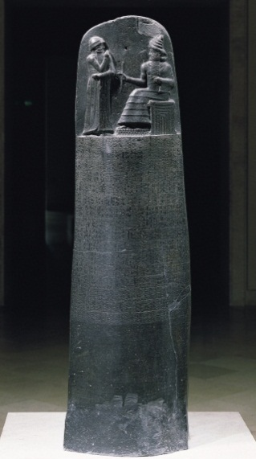 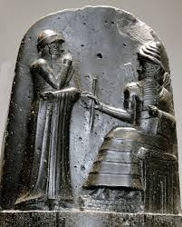 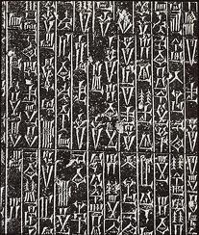

In about 1780 B.C.E., at the height of his power, Hammurabi created 282 laws on an eight-foot-high stele made of black basalt.  Although the Code of Hammurabi is not the first legal code, it is the best preserved ancient law the world has today.

Using 51 columns of cuneiform script, Hammurabi's stele is engraved in the Babylonian language of Akkadian. It originally stood in Babylon's temple of Marduk.

At the top of the stele is Hammurabi, standing on a sacred mountain before Shamash, the sun god and patron of law and justice. Hammurabi's right hand is raised in front of his face, in prayer. The image shows us how law and justice reigned supreme in the land of Babylon, and everyone, even the King, must respect it.

The Code is notable for enlightened laws that exist side by side with cruel punishments. Aside from the well-known "eye for an eye" (law 196) and "tooth for a tooth" (law 200), the Code includes other pronouncements (like whoever builds a poor house will be put to death). At the same time, Hammurabi includes judicial procedures where a man's oath is everything (even when it is proven to be false).

Actual Laws from the Code of Hammurabi

**1**  
If a man bring an accusation against a man, and charge him with a capital crime, but cannot prove it, he, the accuser, shall be put to death.

**22**

If anyone is committing a robbery and is caught, then he shall be put to death.  
**148**  
If a man’s wife becomes afflicted with disease, and if he decides to take another wife, he may. His wife, who is afflicted with disease, he shall not get rid of her. She shall remain in the house which he has built and he shall take care of her as long as she lives.  
**149**  
If that woman decides not to remain in her husband’s house, he shall pay the dowry which she brought from her father’s house and she may go.  
**153**  
If a woman bring about the death of her husband for the sake of another man, they shall impale her.  
**195**  
If a son strikes his father, they shall cut off his fingers.  
**196**  
If a man destroy the eye of another man, they shall destroy his eye.  
**197**  
If one break a man’s bone, they shall break his bone.  
**200**  
If a man knocks out a tooth of a man of his own rank, they shall knock out his tooth.  
**218**  
If a physician operate on a man for a severe wound with a bronze lancet [surgical knife] and cause the man’s death; or open an abscess (in the eye) of a man with a bronze lancet and destroy the man’s eye, they shall cut off his fingers.  
**225**  
If he operates on an ox or a donkey for a severe wound and causes its’ death, he shall give the owner of the ox or donkey 1/4 its value.  
**229**  
If a builder build a house for a man and do not make its construction firm, and the house which he has built collapse and cause the death of the owner of the house, that builder shall be put to death.  
**250**  
If a bull, when passing through the street, gore a man and bring about his death, this case has no penalty.