Valentine's Day

We will be acknowledging Valentine's Day on **Friday, February 14, from 3:00-3:30pm.**

Students can bring individual Valentine's or Cards to pass out to the students in our class. Additionally, students should also bring a small bag for their Valentine’s. Please use the class list below so no one is forgotten. We do not need any additional treats, but thank you for thinking of us!

Thank you,

Mr. D and Class

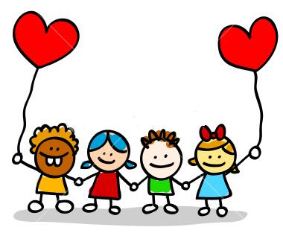 CLASS LIST

1. Nour AbuSabha
2. Hasan AbuSalim
3. Sara Aldulaimi
4. Hussain Ali
5. Zaid Almontesar
6. Hussien Alrabiah
7. Lujain Alsandaqchi
8. Jairo Barba
9. Ivan Bautista
10. Wade Carden
11. Arianna Clark
12. Aaliyah Crowe
13. Kyleigh Diedrich
14. Farah Fahs
15. Hussein Fakih
16. Youssaf Gatea
17. Manny Head
18. Maggie Kanclerz
19. Jaylen Lesinsky-Kujat
20. Joey Muscat
21. Saeed Othman
22. Zaina Refai
23. Ayah Saleh
24. Adrian Smith
25. Kasey Tran
26. Vinnie Waske
27. 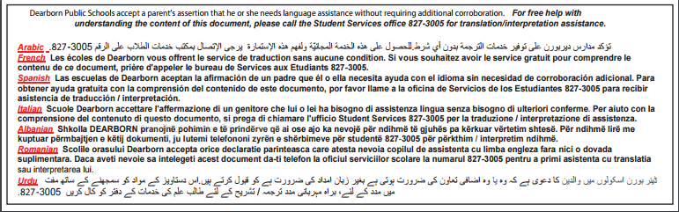Malaak Yahya