Valentine's Day

We will be acknowledging Valentine's Day on **Thursday, February 14, from 10:00-10:30 am**.

I will be bringing in cupcakes for the class. We do not need any additional treats. However, students can bring individual Valentine's Cards to pass out to the students in our class. Additionally, students should also bring a small bag for their Valentine’s. Please use the class list below so no one is forgotten.

Thank you,

Mr. D and Class

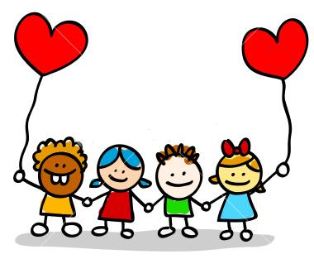 CLASS LIST

1. Zain Abuomarah
2. Abdulfattah Alaboud
3. Amjad Alhadheri
4. Ali Alkirsh
5. Rowan Almontesar
6. Marcus Attard
7. Sidney Busch
8. Victor Canales
9. Nezar Chihry
10. Sahar Daoud
11. Lukas Dobos
12. Allie Donakowski
13. Sophia Dowell
14. Cheyenne Halpin
15. Mahmoud Hazimeh
16. Matt Herman
17. Bayan Khashafa
18. Larissa Lakis
19. Damya Long
20. Khalid Mojali
21. Yesara Obaid
22. Xander Petersen
23. Jayda Ragin
24. Yasmeen Saeed
25. Munira Saleh
26. Saleh Saleh
27. Jason Smith
28. Miles Whitaker

29. Fatima Yahya

