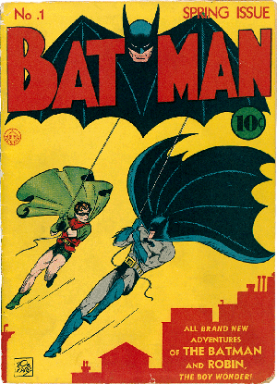

**Rising Action –**

**Batman & Robin are chasing after The Joker.**

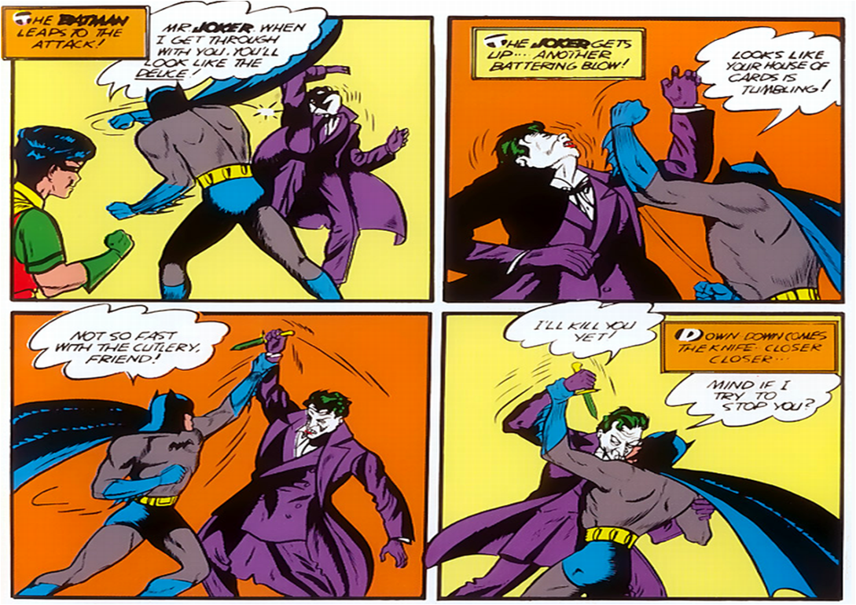

**Climax –**

**Batman & Robin battle The Joker.**

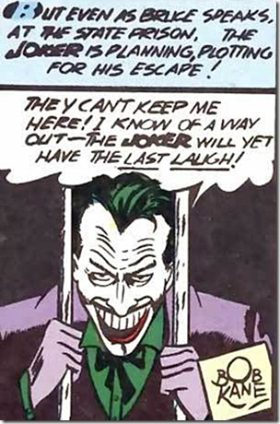

**Falling Action –**

**The Joker is put in jail.**