Dear Parents –

Kindergarten is learning about economic goods and services. This is a difficult concept for the children to understand without them having the hands-on experience. The kindergarten team would like to provide the hands-on experience for the children by creating “Kinder Kash” and providing the children time to “buy” products from our “kinder Store” or “Kinder Kafe” and receive services from our “Kinder Spa.”

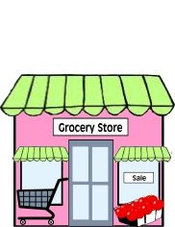The children will rotate between the three areas to participate in each good or service. During the week, the children will be working to earn the “Kinder Kash.” Children can earn “Kinder Kash” for following directions, being a good friend, producing their best work, etc. The children will be responsible for keeping their “Kinder Kash” throughout the week.

The “kinder Store” will sell “kinder-made” products that each class has created; as well as other store bought goods.

The “Kinder Kafe” will sell savory and sweet food items, as well as juice and water.

The “Kinder Spa” will provide nail painting, tattoo application, and face painting services.

**The Kindergarten Goods & Services activity will take place on Friday, December 16th at 2:00pm**.

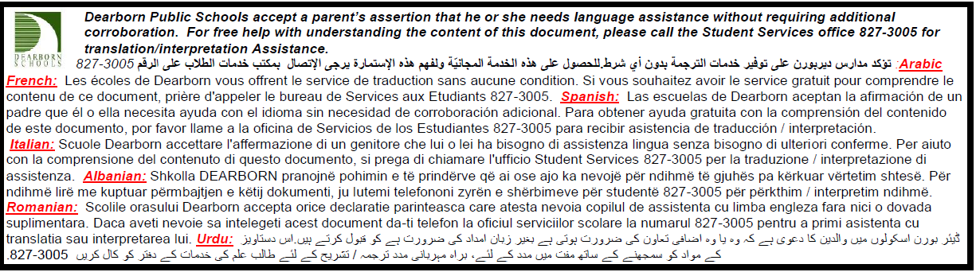Students must return a signed permission slip in order to participate in all activities. Please fill out the slip below, cut it off, and return it in your child’s green folder. All permission slips are due back by Friday, December 9th.

_ _ _ _ _ _ _ _ _ _ _ _ _ _ _ _ _ _ _ _ _ _ _ _ _ _ _ _ _ _ _ _ _ _ _ _ _ _ _ _ _ _ _ _ _ _ _ _ _ _ _ _ _ _ _ _ _ _ _

Please check below to give consent for your child to receive services at the “Kinder Spa.”

I give my permission for my child to participate in all of the above activities

I would like to volunteer to help with the Kindergarten Goods & Services activity

Child’s name: __________________________ Parent name: _________________________