**SAT RELEASED TEST ADMINISTERED ON APRIL 10, 2018**

**CLASSROOM SAT SESSION #7**

**Calculator Portion Released Test: Fordson: 38%**

**District: 38%**

**State: 42%**

19.) In the xy-plane, the graph of line l has slope 3. Line k is parallel to line l and contains the point (3, 10). Which of the following is an equation of line k?

A.) y = - $\frac{1}{3}$ x + 11

B.) y = $\frac{1}{3}$ x + 9

C.) y = 3x + 7

D.) y = 3x + 1

The first question you have to ask yourself is: What do I know about the slopes of parallel lines?

______________________________________________________________________________

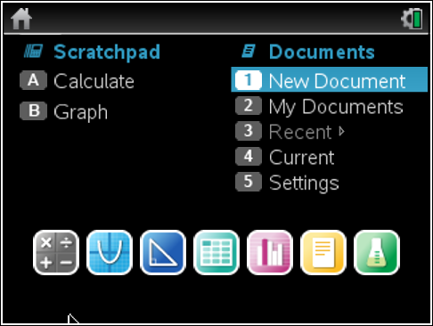

Press the Home Key.

Select 1: New Document

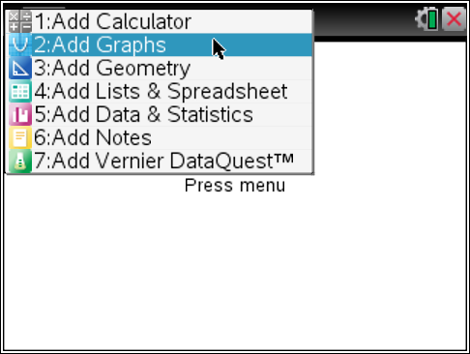Press Enter

Select 2: Add Graphs

The crucial information you have to remember is that parallel lines have the same slope.

So, if line l has slope 3, then line k has slope 3.

Therefore, with this knowledge, what does it do to my answer choices?

_____________________________________________________________________________

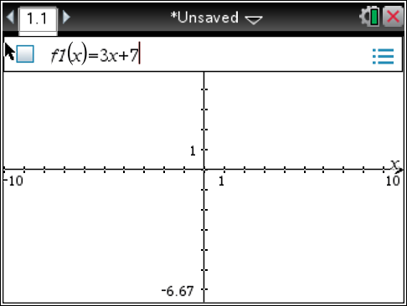Press Enter

Type in answer choice C.

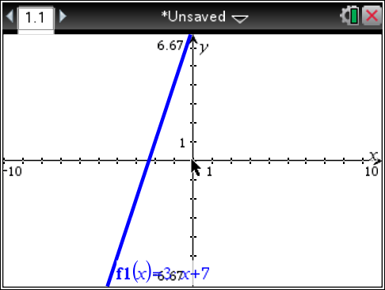

Press Enter.

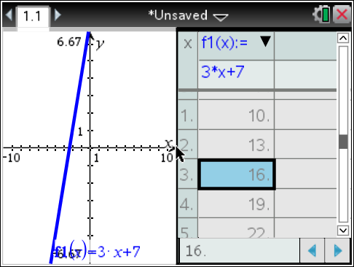Now we have to see if the point (3, 10) is on the line.

Press the CTRL Key

Press the T Key

This will bring up the table. Look at x = 3.

When x = 3, y = 16.

Therefore, we cannot choose C.

Technically, we are done! Since answer choice D is the only one left with 3 as a slope, we can just choose D and move on. However, I would just like to repeat the steps we did to show it to you. On the real SAT you would not do this. But for educational purposes, we are just going to explore.

Press the CTRL Key

Press the ESC Key

This is the edit undo feature of the TI Nspire.

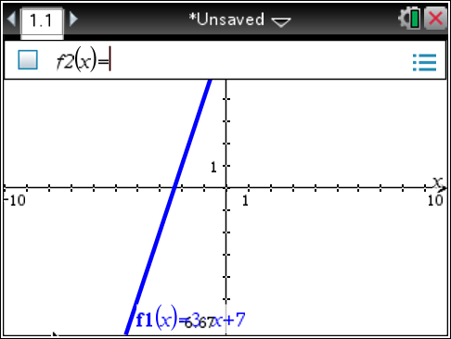

Press the Tab Key

Do you notice that the Nspire says f2(x)?

I want it to go back to f1(x)

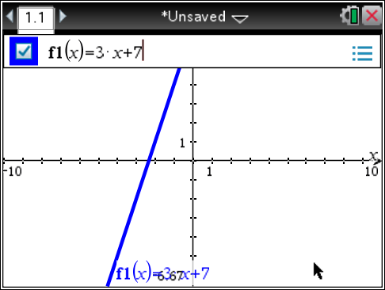Press the Up Arrow

Now you can just edit this equation.

For answer choice D the equation is:

y = 3x + 1

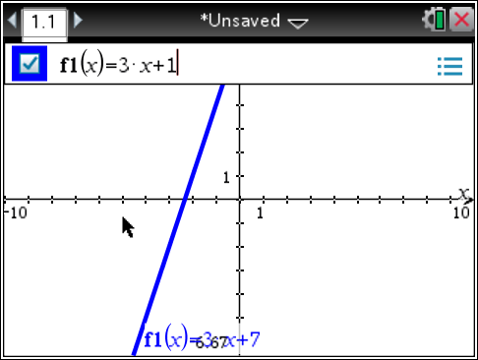

So just change the 7 to a 1.

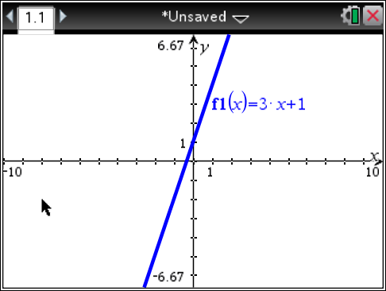Press Enter.

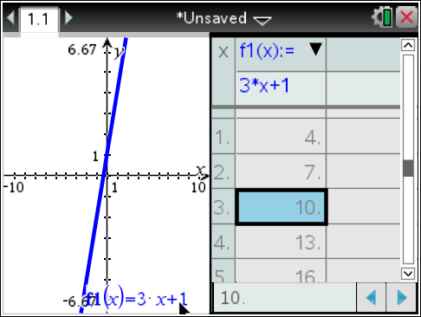

Press the CTRL Key

Press the T Key

When x = 3, y = 10. Therefore, the correct answer choice is D.

Now, since we are still exploring, I want to show you how tricky the College Board can be.

Let’s pretend that we did not know that parallel lines have the same slope.

There is another fact about perpendicular lines. With perpendicular lines the slopes are opposite reciprocals. So in answer choices A and B, they were trying to trick you with that fact for perpendicular lines. Answer choice A had the correct slope for a perpendicular line, but answer choice B did not have the “opposite” part.

Let’s look at these two graphs and the points on their lines.

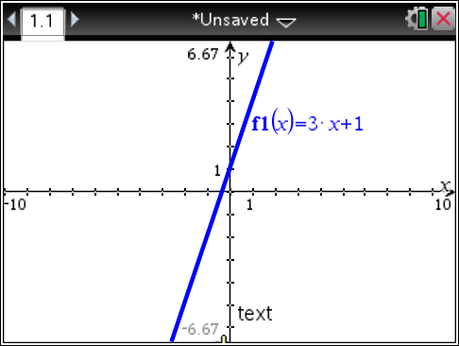Press the CTRL Key

Press the ESC Key

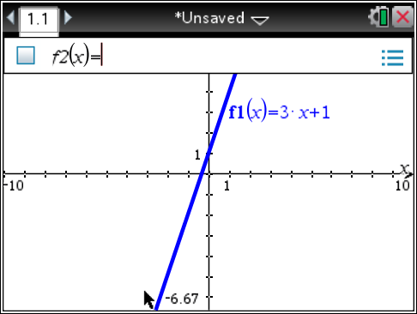Press the Tab Key

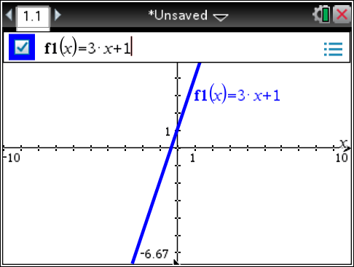

Press the Up Arrow

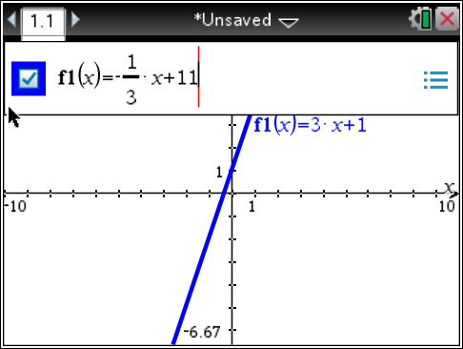Let’s put in answer choice A.

A.) y = - $\frac{1}{3}$ x + 11

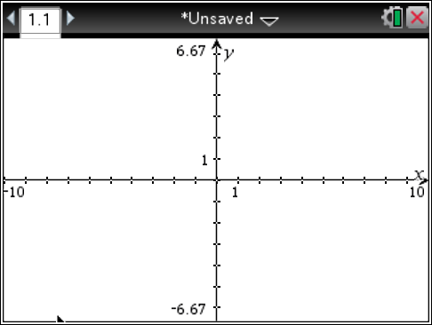Press Enter.

You can’t see the graph, but that is OK.

We want to get the table.

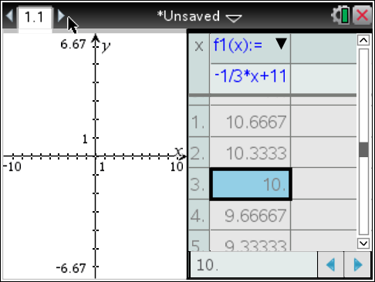

Press the CTRL Key

Press the T Key

When x = 3, y = 10

Some students would get tricked into choosing answer choice A since the line has the point (3, 10) on it.

However, the equation: y = - $\frac{1}{3}$ x + 11, will not be parallel to line line l.

This was a deliberate choice of an equation to trick you!

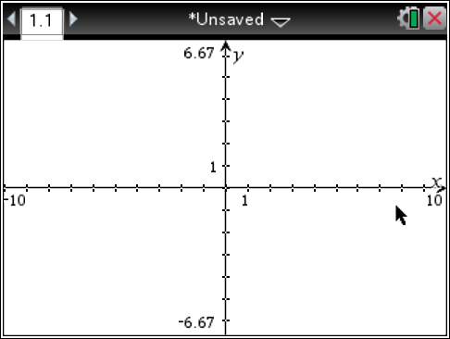Press the CTRL Key

Press the ESC Key

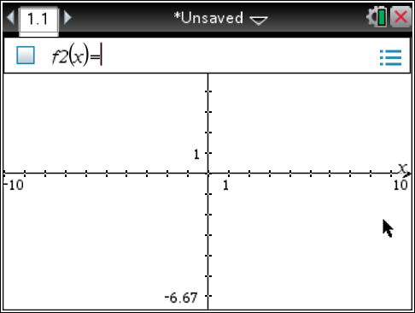Press the Tab Key

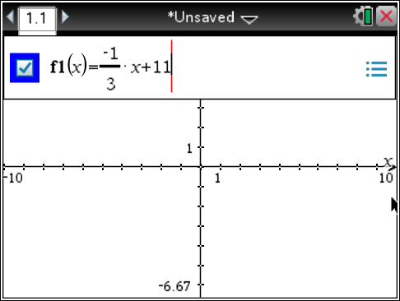Press the Up Arrow

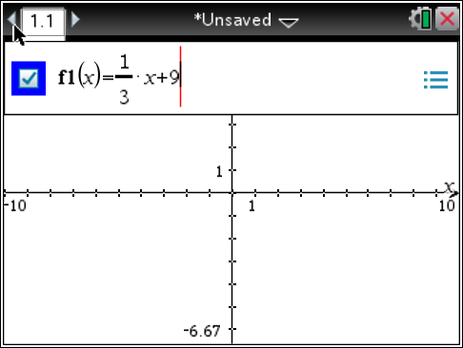Edit the equation so we can check out answer choice B.

B.) y = $\frac{1}{3}$ x + 9

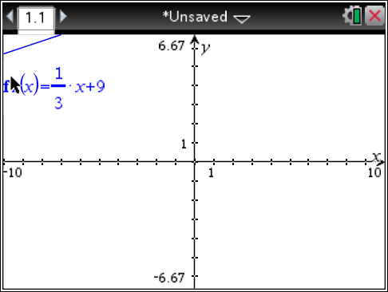Press Enter.

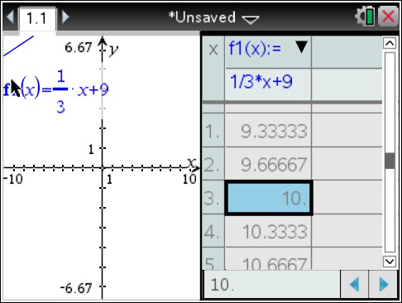Press the CTRL Key

Press the T Key

When x = 3, y = 10

The College Board is definitely trying to distract you from choosing the correct answer choice.

The line would not be parallel or perpendicular. It would be considered a neither.

So for you to be successful on this problem, you had to remember that parallel lines have the same slope.

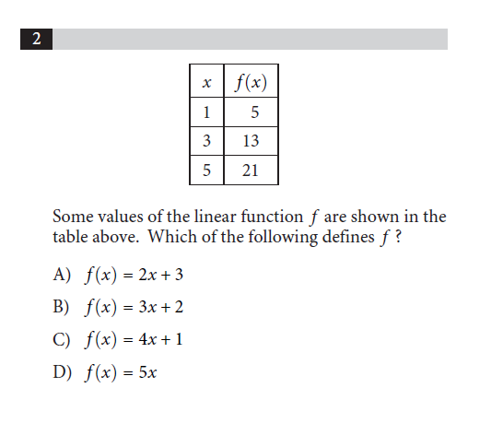**SAT Released Test #5**

**TI NSpire Steps**

1.) Classroom Session #1 uses question 6 on the calculator portion of the SAT test given on April 10, 2018

**TI NSpire Calculator Skill:**  “Solving Linear Systems” on the TI Nspire

2.) Classroom Session #2 uses question 5 on the calculator portion of the SAT test given on April 10, 2018

**TI NSpire Calculator Skill:**  Boolean Checking on the TI Nspire

3.) Classroom Session #3 uses question 8 on the calculator portion of the SAT test given on April 10, 2018

**TI NSpire Calculator Skill:** Storing values for variables on the TI Nspire

4.) Classroom Session #4 uses question 6 on the calculator portion of the SAT test given on April 10, 2018

**TI NSpire Calculator Skill:**  “Solving Linear Systems” on the TI Nspire

5.) Classroom Session #5 uses question 17 on the calculator portion of the SAT test given on April 10, 2018

**TI NSpire Calculator Skill:** Finding Population Standard Deviation on the TI Nspire

6.) Classroom Session #6 uses question 18 on the calculator portion of the SAT test given on April 10, 2018

**TI NSpire Calculator Skill:** Finding Linear Regression on the TI Nspire

7.) Classroom Session #7 uses question 19 on the calculator portion of the SAT test given on April 10, 2018

**TI NSpire Calculator Skill:** Graphing an equation and making a table on the TI Nspire