  The chimpanzee is a type of ape that is found in different habitats. Their habitat is mostly in middle and western Africa. Chimpanzees live in forests and grasslands.

         Chimpanzees eat both plants and animals. They eat fruit, seeds and flowers that they pick from the trees. They also eat insects which they dig from the ground with their hands or a stick.

         They play and sleep mostly in the treetops. The chimpanzee swings from branch to branch to move around their habitat. They use their fingers and toes to help grip the branches as they swing in the trees. Every night, they build a nest in the trees to sleep.

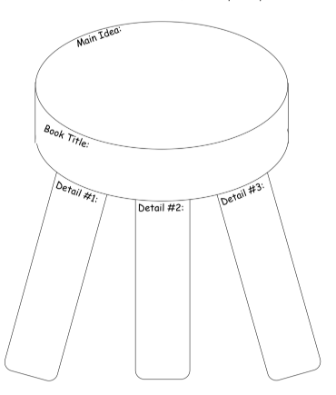**.**

**What is the main topic of this passage?**

|  |
| --- |
|  |

2. **What is the main focus of paragraph one?**

a. Chimpanzees live in the middle of Africa

 b. Chimpanzees live in forests

c. Chimpanzees are found in different habitats

d. Chimpanzees are a type of ape

|  |
| --- |
|  |

3. **What is the main focus of paragraph two?**

a. Chimpanzees eat plants and animals

b. Chimpanzees eat insects

c. Chimpanzees dig insects from the ground

d. Chimpanzees eat fruit, seeds and flowers

|  |
| --- |
|  |

4. **What is the main focus of paragraph four?**

a. They swing from branch to branch

b. They play and sleep in the treetops

c. They use their fingers and toes to grip the branches

d. They build a nest in the trees to sleep

|  |
| --- |
|  |