**Name_______________________________HR______**

**Chapter 3 From Hunters and Gatherers to Farmers Study Guide – This is due on Wednesday.**

1. Define the following vocabulary words:

* **Domesticate:**
* **Agriculture:**
* **Nomad:**
* **Trade:**
* **Resource:**
* **Hunters and Gatherers:**
* **Paleolithic Age:**
* **Neolithic Age:**
* **Fertile Crescent:**
* **Catal Hoyuk:**

1. If you were a Neolithic trader, what would most likely happen as you traveled and traded?
2. How did trade help Neolithic people make stronger tools?
3. Why did Neolithic people trade?
4. What is the best title for these words: Spinners, Weavers, Basket Makers and Toolmakers?_________________________________________
5. Archaeologists have found decorated pottery and polished stones. What does this suggest about Neolithic people?
6. How did dividing up the work help communities produce more to meet their needs?
7. What was a change that resulted from building permanent shelters?
8. Why did people in the Neolithic Age live together in larger groups, compared with earlier times?
9. Archaeologists have found houses in which the doorways were built high up on the walls. What was the reason for this?
10. One animal that was domesticated mainly for meat and milk was the _____________.
11. What was the greatest benefit to people when early farmers began to raise plants and animals?
12. Why was the Fertile Crescent the site of many early settlements?
13. What change began the Neolithic Age in about 8000 B.C.E.?
14. What ended the Neolithic Age in about 3000 B.C.E.?
15. How did people in the Paleolithic age get their food?
16. Label the following countries and physical features.

**Nile River Sahara Desert South Africa Madagascar Kenya Somalia Egypt**

**Sudan South Sudan Ethiopia Algeria Morocco Libya Liberia**

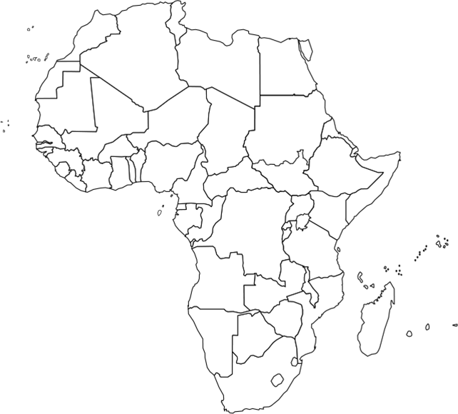

1. **Be prepared to answer this question in a short answer on your test.**

How did the development of agriculture change daily life during the Neolithic Age?