**THIS IS DUE THE DAY OF YOUR TEST!:)**

Unit 1 Study Guide. Name_________________________________HR___

Define the following vocabulary words

1. **Equator –**
2. **Latitude –**
3. **Geography –**
4. **Longitude –**
5. **Meridian -**
6. **Scale -**
7. **Compass Rose –**
8. **Cardinal Direction -**
9. **Key-**
10. **Grid –**
11. **Population Density-**
12. **Fossil Fuels -**
13. **Natural Resource –**
14. **Vegetation:**
15. True or False – All Distance Scales will be the same distance.
16. True or False – 20º W and 30 º N are correct coordinates found on a map.
17. What are the 4 factors that effect climate?
18. What are the 5 parts of a map?
19. What are the 5 major climates?
20. What is the first thing you look at when you look at a map?
21. What are the 3 types of natural resources?
22. What is the difference between weather and climate?
23. Why is the birth rate now exceeding the death rate in the last 100 years?
24. What factors affect population density?
25. How are climate and vegetation related?
26. Where did most civilizations begin?
27. Label the 7 continents and 4 oceans.

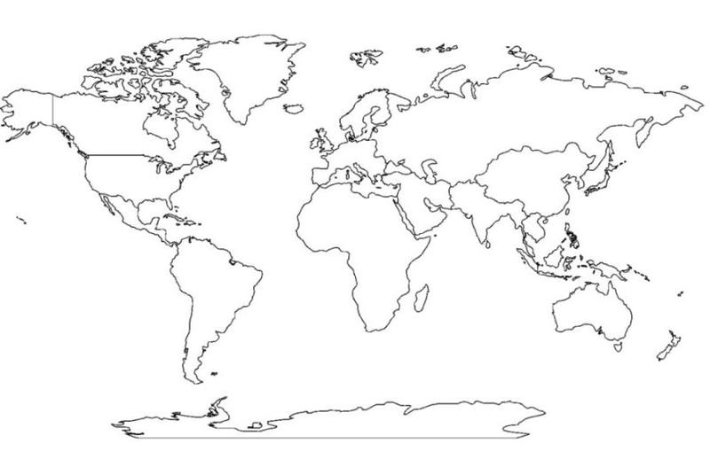

Use the map below to help you answer the following questions. You may want to make a scale.

1. How many miles is the scale worth on Map B?
2. Approximately how many miles is it from Kuwait City to Abdali?
3. Approximately how many miles is it from Al Jahrah to Al Wafrah?
4. What is the name of Michigan’s Climate?