**Annotation Guidelines**

When you TTTT (annotate) you must highlight important sections.

Use sentence stems on the back (or create your own), to explain your thinking for the parts you have highlighted.

**All responses must be in**

**complete sentences.**

Vocabulary should be words that are new to you and/or important to the understanding of the text.

Remember to use highlighter for highlighting and a pen or pencil for your writing.

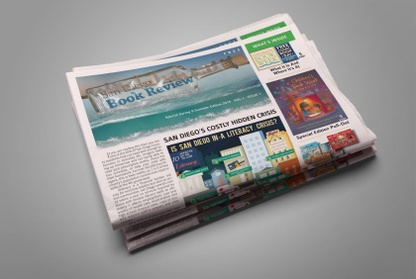

**Annotation Guidelines**

When you TTTT (annotate) you must highlight important sections.

Use the sentence stems on the back (or create your own), to explain your thinking for the parts you have highlighted.

**All responses must be in**

**complete sentences.**

Vocabulary should be words that are new to you and/or important to the understanding of the text.

Remember to use highlighter for highlighting and a pen or pencil for your writing.



|  |
| --- |
| **Annotation Sentence Starters**  **Questions**  Who? What? When? Where? Why? How?  I wonder ______________?  I didn't understand this part because….  **Comments**  I agree/disagree with ____ because ____.  I enjoyed reading this because _____.  I did not enjoy reading this because _____.  What was entertaining, informative, or useful about what I read?  **Connections**  Explain what this reminds you of from the world, your life, another text, or another subject.  This reminds me of….  I connected to this when…  This relates to my life because…  This makes me think about…  This part makes me remember…  I had a strong connection to this part because…  This is familiar to me because…  This is similar to…  ___ made me remember a time when…  **Predict**  I think _____ will happen because _____.  I think I will learn _____ because ____.  **Summarize**  The important things in this part of the text are ____.  Explain the main idea of the chunk briefly.  **Visualize**  Draw a picture or visual of what you just read.  **Infer**  Because the story says ___, I think ____  I can infer that ____ because ____.  Based on what the text says and what I know, I think…  Although the writer does not come right out and say it, I can figure out that …  **(Vocabulary)**  Identify vocabulary that is new to you. You may define them.  Identify words that are important to the text |
| **Annotation Sentence Starters**  **Questions**  Who? What? When? Where? Why? How?  I wonder ______________?  I didn't understand this part because….  **Comments**  I agree/disagree with ____ because ____.  I enjoyed reading this because _____.  I did not enjoy reading this because _____.  What was entertaining, informative, or useful about what I read?  **Connections**  Explain what this reminds you of from the world, your life, another text, or another subject.  This reminds me of….  I connected to this when…  This relates to my life because…  This makes me think about…  This part makes me remember…  I had a strong connection to this part because…  This is familiar to me because…  This is similar to…  ___ made me remember a time when…  **Predict**  I think _____ will happen because _____.  I think I will learn _____ because ____.  **Summarize**  The important things in this part of the text are ____.  Explain the main idea of the chunk briefly.  **Visualize**  Draw a picture or visual of what you just read.  **Infer**  Because the story says ___, I think ____  I can infer that ____ because ____.  Based on what the text says and what I know, I think…  Although the writer does not come right out and say it, I can figure out that …  **Vocabulary**  Identify vocabulary that is new to you. You may define them.  Identify words that are important to the text |