**WWI Poster Assignment**

During times of war it is common for a government to use propaganda posters in order to raise money or support. In order to make sure you fully understand the impact these posters had on the war effort, your job will be to create a war effort poster that meets the following standards and addresses the following issues:

**Standards and Issues:**

* Posters must be relevant to the topic and school appropriate
* Posters must fill up a majority of the paper given to you
* Posters must be colorful
* Posters must be **PRO-**American
* Posters must have at least one central image and one slogan enticing the American people to either **buy war bonds, gladly accept rations, collect items, grow their own food**, **or support the war in another way (ex. join the military)**.
* Finally, it needs to convince me that the goods you are selling are worth buying into

**Guidelines:**

In order to receive full credit, your poster **must** meet the following requirements:

1. The posters theme must use one of the central images listed above (10 pts)
2. It **must** be pro-American and have a creative slogan (10 pts)
3. It **must** be colorful! (5 pts)

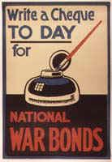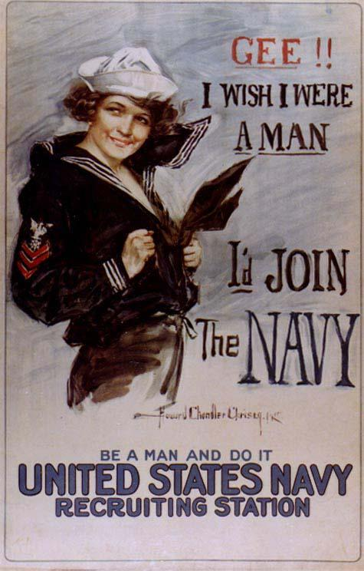

**WWI Poster Examples:**

