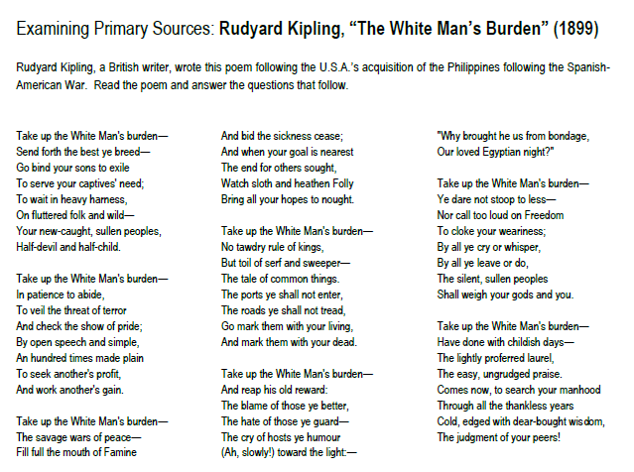

1. Describe what you think Kipling means by “the white man’s burden”.
2. Underline 2-3 words/phrases used to describe imperialized (African) people. How do these descriptions reveal Kipling’s attitude towards these people?
3. Imagine that you are a Filipino or other native resident of an imperialized nation. How might you react to this poem? Explain in detail.
4. Do you think the imperial powers thought they were helping those they imperialized? Why or why not? Provide evidence & reasoning.



1. Describe what you think Kipling means by “the white man’s burden”.
2. Underline 2-3 words/phrases used to describe imperialized (African) people. How do these descriptions reveal Kipling’s attitude towards these people?
3. Imagine that you are a Filipino or other native resident of an imperialized nation. How might you react to this poem? Explain in detail.
4. Do you think the imperial powers thought they were helping those they imperialized? Why or why not? Provide evidence & reasoning.