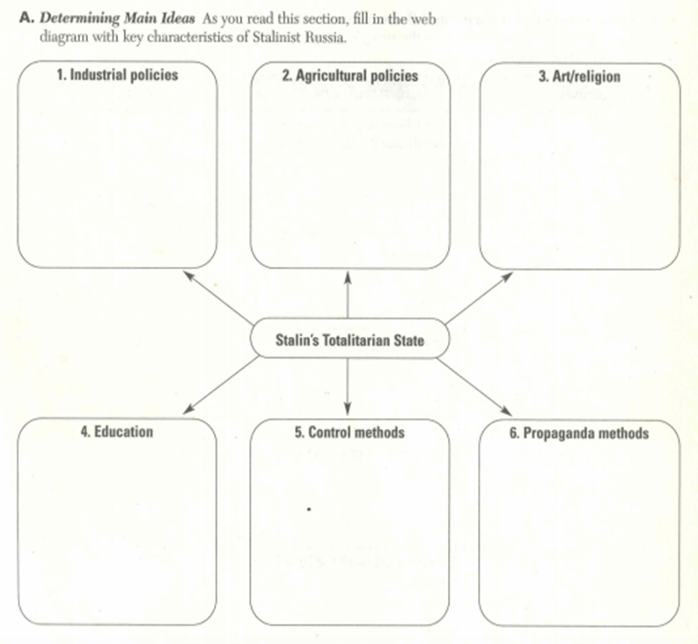**Totalitarianism Bubble Map**

**Stalin’s Totalitarian State**

**Map Guiding Question:** How would you describe Totalitarianism? (Use p. 875)

**Frame Guiding Question:** What have you learned from this description?