**More Causes of the French Revolution**

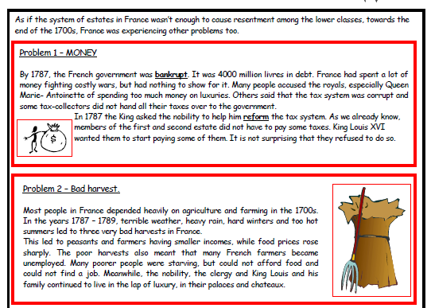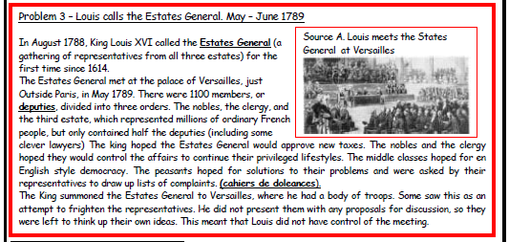Directions: Answer the following questions about causes of the French Revolution using the readings below.

1. Why was the French Government bankrupt in 1787? Give 2 reasons.

2.) What effect did the poor harvest have on the ordinary people of France?

3.) Why might members of the third estate have felt under-represented at the meeting of the Estates General in May 1789?

4.) What were the hopes of each of the parties involved?

King:

Middle class:

Peasants:

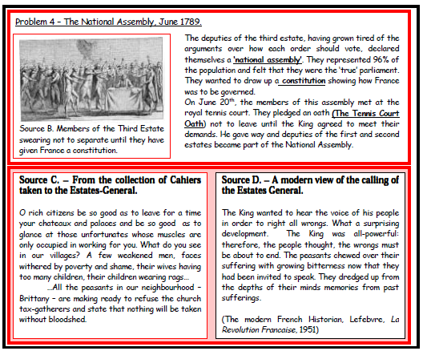

5.) What mistakes did King Louis make at the meeting, and what did his mistakes lead to? (clue: problem 4)

6.) Read source C. According to this source, what were French villages like? Were they all like the one described? Explain.

7.) What are the peasants of Brittany threatening at the end of source C? Use words from the source to add detail to your answer.

8.) What does the author of source D think about the calling of the Estates General?

9.) Using the information on this sheet, and your previous notes on the French Revolution, write a one paragraph including evidence answer to the question:

**Why was France on the brink of revolution by 1789?**