Name: __________________________________________ Period: _____ Score: ______

The Black Death Sourcework

Source 1: from *The Black Death Approaches-* “We see death coming into our midst like black smoke, a plague which cuts off the young, a rootless phantom which has no mercy or fair countenance. Woe is me… It is an ugly eruption that comes with unseemly haste. It is a grievous ornament that breaks out in a rash” –Jevan Gethin

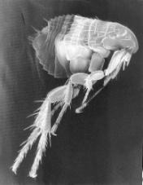In the autumn of 1347, a fleet of Genoese trading ships loaded with grain left the Black Sea port of Caffa and set sail for Messina, Sicily. By mid-voyage, sailors were falling sick and dying. Soon after the ships tied up at Messina, townspeople, too, began to fall sick and die. Within months, the disease that Europeans called the Black Death was raging through Italy. By 1348, it had reached Spain and France. From there, it ravaged the rest of Europe where one in three people died. See the map below.

Source 2: Map depicting the spread of Plague in Europe

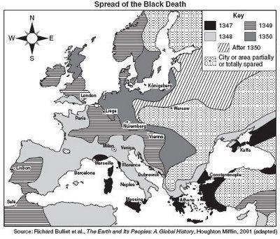 The sickness was mostly bubonic plague, caused by bacteria carried by fleas that lived on black rats. In crowded, filthy medieval cities, houses were close together, and residents threw garbage and human waste into the streets, allowing for the perfect habitat for black rats. They infested ships, towns, and even the homes of the rich and powerful, so no one took any notice of them. Black rats thrived on ships and moved from port to port, bringing their fleas with them. Rats, however, were susceptible to the disease and as they began to die from the plague, fleas sought new hosts from which to feed, i.e.…humans.

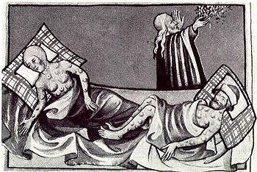Once infected, death was inevitable and occurred swiftly, usually within three or four days. The first signs of infection appeared within two days of exposure and included dark, almost black buboes, or boils, that appeared in the infected person’s armpits and groin area. It was for these dark buboes that Black Death was named. A sudden high fever and severe pain throughout the body, especially in the joints, accompanied the buboes. As symptoms progressed, victims were unable to sleep, went into convulsions and had severe headaches that led to deliriums. Their eyes went bloodshot and tongues swelled horrifically and went dry. Many of those infected vomited virtually nonstop for the short remainder of their lives.

Source 3: Excerpt from the *Decameron* describing the symptoms of the plague - The symptoms were not the same as in the East, where a gush of blood from the nose was the plain sign of inevitable death; but it began both in men and women with certain swellings in the groin or under the armpit. They grew to the size of a small apple or an egg, more or less, and were vulgarly called tumors. In a short space of time these tumors spread from the two parts all over the body. Soon after this the symptoms changed and black or purple spots appeared on the arms or thighs or any other part of the body, sometimes a few large ones, sometimes many little ones. - Giovanni Boccaccio

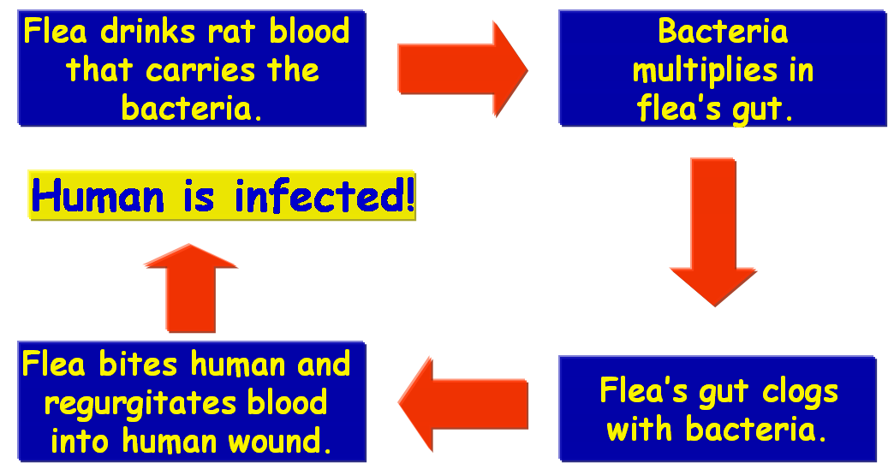**Forms of the Plague:** Diagram of how Bubonic Plague is spread

Bubonic plague – This strain attacks the lymph nodes, found in the human neck, armpit and groin. When infected with the plague, these areas become very swollen and turn dark blue or nearly black in color. This is the least deadly of the three plagues because it cannot be transmitted between humans without a carrier, such as a flea. Mortality rate: 30-75% (Today, treated with antibiotics)

Pneumonic Plague – This form attacks the lungs and can be transmitted easily via common air. Death usually occurs with 3-4 days. Mortality rate: 90-95% (Today, treated with antibiotics)

Septicemic Plague – This strain attacks the blood and brain, and is the most deadly form of the disease, with death often occurring within 24 hours. Mortality rate: nearly 100% (No cure available)

Source 4: Medieval attempts to cure or ward off the plague. Taken from the *Decameron*

|  |  |
| --- | --- |
| **Vinegar & Water** | If a person gets the disease, they must be put to bed. They should be washed with vinegar and rose water |
| **Lancing the Buboes** | The swellings associated with the Black Death should be cut open to allow the disease to leave the body. A mixture of tree resin, roots of white lilies and dried human excrement should be applied to the places where the body has been cut open |
| **Bleeding** | The disease must be in the blood. The veins leading to the heart should be cut open. This will allow the disease to leave the body. An ointment made of clay and violets should be applied to the place where the cuts have been made |
| **Diet** | Do not eat food that goes off easily and smells badly such as meat, cheese and fish. Instead one should eat bread, fruit and vegetables |
| **Sanitation** | The streets should be cleaned of all human and animal waste. It should be taken by a cart to a field outside of the village and burnt. All bodies should be buried in deep pits outside of the village and their clothes should also be burnt |
| **Medicine** | Roast the shells of newly laid eggs. Ground the roasted shells into a powder. Chop up the leaves and petals of marigold flowers. Put the egg shells and marigolds into a pot of good ale. Add treacle and warm over a fire. The patient should drink this mixture every morning and night |
| **Witchcraft** | Place a live hen next to the swelling to draw out the pestilence from the body. To aid recovery you should drink a glass of your own urine twice a day |

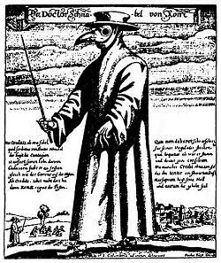Outbreaks of the plague continued for centuries. To ward off infections, doctors from the 1600’s (pictured right) wore a leather mask with glass eyes and a long beak filled with herbs and spices.

**Normal Life Breaks Down**

In Europe, the plague brought terror and bewilderment, as people had no way to stop the disease. Some people turned to magic and witchcraft for cures. Others plunged into wild pleasures, believing they would soon die anyway. Still others saw the plague as God’s punishment. They beat themselves with whips to show that they repented their sins (pictured below) and would be known as flagellants. The movement became popular after the disillusionment with the Church’s reaction to the Black Death. Normal life broke down as people fled cities or hid in their homes to avoid contracting the plague from neighbors and relatives.

Source 5: Depiction of Medieval Flagellants

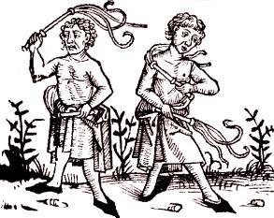Fear and ignorance led people to blame the disease on groups who were already hated. In Spain, the Muslims were blamed, in France, the English. But Jewish people more than any other group, were singled out. Because Jews were less susceptible to the Black Death than their neighbors (likely the result of Jewish ritual regarding personal hygiene), Jews were accused of poisoning the wells. In one Swiss town, every Jew was rounded up and burned to death (below). Hundreds of other massacres of Jews took place in Europe during the plague

Source 6: Burning of Jews accused of spreading the Black Death

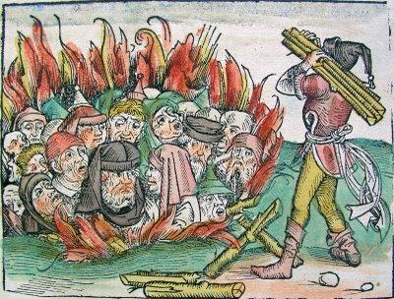**The Economy Suffers**

As the plague kept recurring in the late 1300’s, the European economy plunged to a slow crawl. When workers and employers died, production declined. Survivors demanded higher wages. Landowners and merchants pushed for laws to limit wages. To limit rising costs, landowners converted croplands to land for sheep raising, which required less labor. Villagers forced off the land looked for work in towns. There, guilds limited opportunities for advancement. Coupled with the fear of the plague, these restrictions sparked explosive revolts. Bitter, angry peasants rampaged in England, France, Germany, and elsewhere. In the cities, artisans fought for more power, usually without success. Revolts erupted on and off through the 1300s and 1400s. The plague had spread both death and social unrest.

**Tasks:** Answer the following questions based on the primary sources and information provided

1. Name the first European country to be affected by the Black Death? (1pt)

2. Looking at Source 2, specifically the years from 1347-1350, what year did the plague cover the most territory

3. Looking at Source 1, what phrases make this description so chilling? Name at least two. (2pts)

a.) b.)

4. What were the conditions and practices in medieval towns that allowed for black rats to thrive? (2pts)

5. How did the Black Death get its name? (1pt)

6. Name at least 2 symptoms people would develop if they contracted the plague? (2pts)

a.) b.)

7. According to Source 3, what two places were plague victims first likely to develop buboes? (2pts)

a.) b.)

8. a.) What was the deadliest form of the plague and b.) where did it attack in the human body? (2pts)

a.) b.)

9. Looking at Source 4, a.) what course of action seems the most sensible? b.) Which one seems the most odd?

a.) b.)

10. How does the outfit worn by doctors ‘protect’ them from the Black Death? (2pts)

11. a.) Who are the people in Source 5 and b.) what are they doing? c.) Why are they doing this? (2pts)

a.) b.)

c.)

12. a.) Who was mostly blamed for causing the plague? B.) How did they ‘spread’ the disease? (2pts)

a.) b.)

13. What is going on in Source 6? (2pts)

a.) b.)

14. How did the Black Death affect the medieval economy? Name at least 2 ways (2pts)

a.) b.)

15. a.) How would you feel if a similar plague broke out in your town? b.) What would you do? c.) How might your view of the world change? (5pts)

a.)

b.)

c.)

Black Death Sourcework Answer Key

1. Name the first European country to be affected by the Black Death? (1pt) **Sicily**

2. Looking at Source 2, specifically the years from 1347-1350, what year did the plague cover the most territory (1pt) **1348**

3. Looking at Source 1, what phrases make this description so chilling? Name at least two. (2pts) **Will Vary**

1. **Death coming into our midst like black smoke** 2) **A rootless phantom which has no mercy**

4. What were the conditions and practices in medieval towns that allowed for black rats to thrive? (2pts)

**Crowded, sanitation practices (threw garbage and human waste into streets)**

5. How did the Black Death get its name? (1pt)

**Dark buboes on armpits, neck, or groin**

6. Name at least 2 symptoms people would develop if they contracted the plague? (2pts)

**Buboes, high fever, severe pain throughout body, unable to sleep, convulsions, severe headaches that led to delerium**

7. According to Source 3, what two places were plague victims first likely to develop buboes? (2pts)

1. **Groin**  2) **Armpit**

8. a) What was the deadliest form of the plague and b) where did it attack in the human body? (2pts)

1. **Septicemic** b) **Blood and Brain**

9. Looking at Source 4, (a) what course of action seems the most sensible? (b) Which one seems the most odd? (2pts

1. ) **Will Vary** b) ) **Will Vary**

10. How does the outfit worn by doctors ‘protect’ them from the Black Death? (2pts)

**Thought to ward off the plague**

11. a) Who are the people in Source 5 and b) what are they doing? c) Why are they doing this? (2pts)

1. **Flagellants** b) **Whipping themselves** c) **To show that they repented their sins**

12. a) Who was mostly blamed for causing the plague? b) How did they ‘spread’ the disease? (2pts)

1. **Jews** b) **Poisoned the wells**

13. What is going on in Source 6? (2pts)

**Burning of the Jews**

14. How did the Black Death affect the medieval economy? Name at least 2 ways (2pts)

**Production declined, Survivors demanded higher wages, converted cropland to land for sheep (required less labor), villagers forced off land so looked for work in towns, revolts**

15. a) How would you feel if a similar plague broke out in your town? b) What would you do? c) How might your view of the world change? (5pts)

a) **Will Vary**

b) **Will Vary**

c) **Will Vary**