**Hinduism Video Questions**

Directions: Answer the following questions & fill in the blanks while watching the Hip Hughes video on Buddhism. https://www.youtube.com/watch?v=IGV6M4wQ8Os

1. Who is the founder or leader of Hinduism?
2. Do you think Hinduism is monotheistic or polytheistic? Support your claim with details.
3. Explain each of the **six** basic Hindu principles.
4. Define dharma in your own words.
5. What does one’s karma determine according to Hindus?
6. Hindus believe that if you follow your _____________ which is dictated by ________________so you can achieve ____________ and free your soul from Earth.

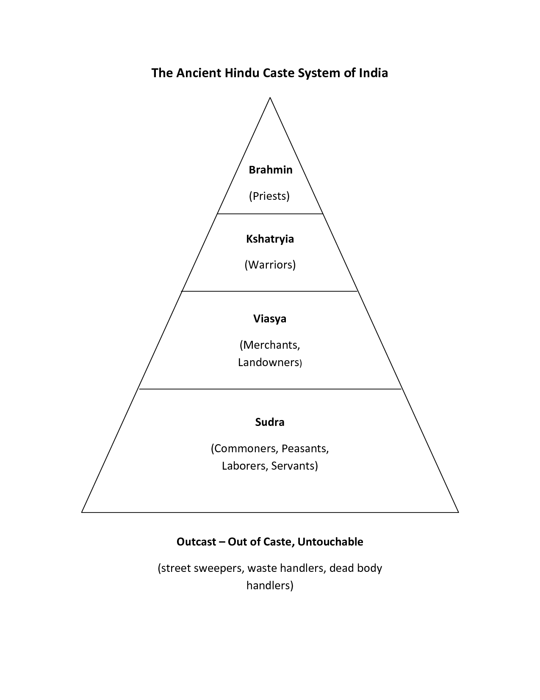Hindus believe in a social class hierarchy called the **caste system**. A hierarchy means that some people are higher and more powerful than others. In the caste system, the highest caste are the priests, second is the warriors and rulers, next are the merchants, landowners, and other middle class people, then the farmers, peasants, common people, and even some servants for families. There is a large group of people who are not valued at all – they aren’t even in the caste system, they are outcasts. They are called the untouchables and are treated basically like slaves in India. They are given the worst jobs like cleaning up the streets and dealing with dead bodies. They are called “untouchable” because people from the castes aren’t supposed to even touch them. If one was born into an upper-caste it is believed that their good fortune was said to come from good **karma** earned in a former life. It is believed that bad karma in a previous life would put one into a lower caste level. Moving from one caste to another happens during **reincarnation**. Only men in the top three tiers could hope to achieve **moksha** in their present lives.

Our textbook states, “Together, the beliefs of Hinduism and its caste structure dominated every aspect of a person’s life. These beliefs deteremined what one could eat and the way in which one ate it, personal cleanliness, the people one could associate with, how one dressed, and so on. Today, even in the most ordinary activities of life, Hindus turn to their religion for guidance” (p. 67).

1.) How has Hinduism influenced social structure in India?

2.) Could one move from one caste to another in the same lifetime? Why or why not?

3.) What could you do in your life to move up in the caste system after you are reincarnated?

4.) Which caste would you hope to be born into? Why?