**Buddhism Video Questions**

Directions: Answer the following questions & fill in the blanks while watching the Hip Hughes video on Buddhism. https://www.youtube.com/watch?v=eYKdEnEqfQQ

1. Buddha’s real name is ___________________________. He was born to a __________________. His father wanted him to stay home because ___________________________________________________.
2. Why do some people believe Buddhism is dharma?
3. Describe each of the **Four Noble Truths**:
   1. Dukkha:
   2. Samudaya:
   3. Nirodha:
   4. Magga:
4. How does a Buddhist achieve nirvana through meditation?

|  |  |
| --- | --- |
| **Right Understanding** | understanding the Four Noble Truths |
|  | control your mind; have determination & resolve in faith |
| **Right Speech** |  |
|  |  |
| **Right Livelihood** | cannot be in a profession involving pain/suffering/violence towards other creatures |
| **Right Mental Effort** |  |
|  | be in touch with ourselves and our feelings |
| **Right Concentration** |  |

1. Complete the chart about the **Eightfold Path** or “The Middle Way”.

|  |  |  |  |
| --- | --- | --- | --- |
| The Laykyun Sekkya Buddha is a statue of Buddha in Myanmar. It is one of the three tallest statues in the world.  The Great Buddha, a statue in Thailand. This is the tallest statue in Thailand, and the ninth-tallest in the world. | 1. What is similar about the statues pictured? Describe two details. 2. What is different? Describe two details. 3. How do these statues show the spread of Buddhism around Asia? Explain. |  |  |

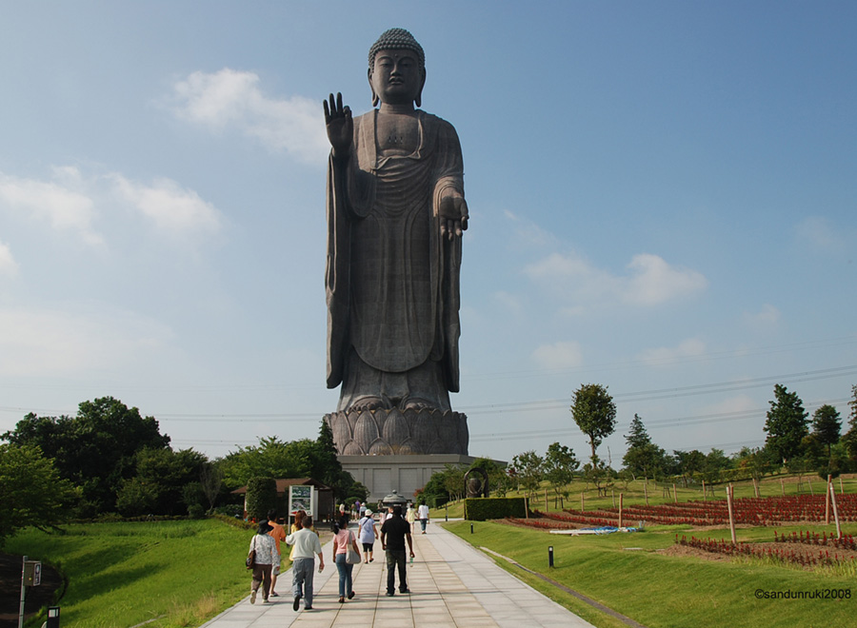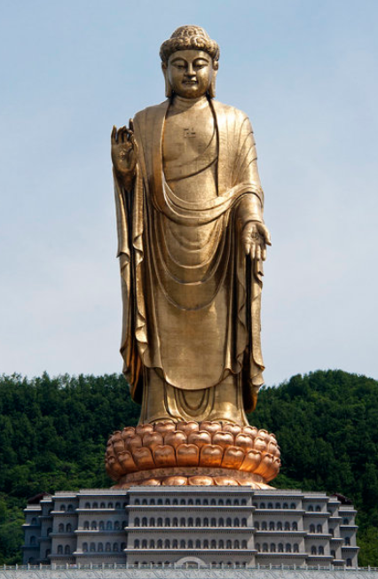

The Spring Temple Buddha, a statue in China is the tallest statue in the world.

Ushiku Daibutsu is a statue of the Buddha located in Japan. It is one of the top three tallest statues in the world.