**Using Desmos to Explore Transformations of the Families of Functions Name: ________________________**

1. Log on to your account and go to the web browser. Type in the following web address for the graphing calculator we will be using:

<https://www.desmos.com/calculator>

2. On the left hand side of the screen, type in: f(x) = x and push enter.

3. On the next line, type in g(x)=a*f(bx – c) +d . On the line below it asks about sliders. Select “All”. It should now look like the screen below. **Make sure the sliders start at a=1, b=1, c=0, and d=0 every time you start a new parent function.**

4. To change the function, just change the equation of f(x). On the following pages, sketch each of the parent function graphs, and then use the sliders to describe the effects of the parameters a, b, c and d.

* To do powers, use the ^ button (shift 6)
* For f(x)=|x|, this is the absolute value function, use abs(x). Look on the functions button of the keypad at the bottom – they are under the third tab (misc), see screen shot below. You can also just type the words.

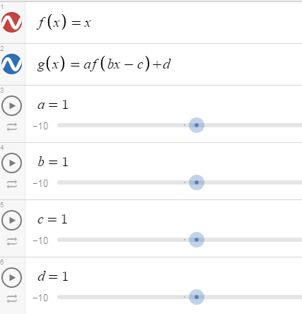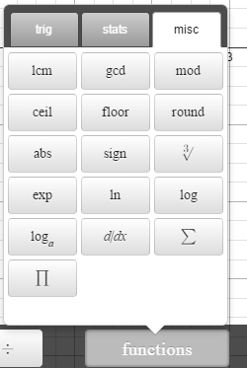

5. Fill in the following table:

|  |  |  |  |
| --- | --- | --- | --- |
| **Absolute Value**  **Parent Equation:**  **Transformed Equation:** | | **Cosine**  **Parent Equation:**  **Transformed Equation:** | |
| http://etc.usf.edu/clipart/49300/49308/49308_graph_1010j_lg.gifDraw graph of parent function and transformed in 2 different colors | Effect of parameter | http://etc.usf.edu/clipart/49300/49308/49308_graph_1010j_lg.gifDraw graph of parent function and transformed in 2 different colors | Effect of parameter |
| **a** | **a** |
| **b** | **b** |
| **c** | **c** |
| **d** | **d** |

|  |  |  |  |  |  |  |  |  |  |  |  |  |  |  |
| --- | --- | --- | --- | --- | --- | --- | --- | --- | --- | --- | --- | --- | --- | --- |
| 7. Given any function, describe the effects of the following parameters on the function f(x) : y = a*f(bx – c) + d  Use the following word bank***: vertical stretch, vertical compression (shrink), horizontal stretch, horizontal compression, vertical translation, horizontal translation.***   |  |  |  |  | | --- | --- | --- | --- | | Parameter a | Parameter b | parameter c | parameter d | | |*a*|> 1 | |*b*|> 1 | *c*> 0 | *d*> 0 | | 0 <|*a*|< 1 | 0 <|*b*|< 1 | *c*< 0 | *d*< 0 | | *a*< 0 | *b*< 0 | |
| 8. Given the following functions, describe the transformations on the parent function, *f*(*x*). Use the vocabulary: translation, stretch, shrink, reflection.  a. a. *f*(*x*) = *x*2; *h*(*x*) = 3(*x* – 4)2 + 2  b. b. *f*(*x*) = *cosx*; *g*(*x*) = cos(3*x*)  c. |
| 9. , Write the equation of the function given the following transformations:  a. a. The graph of  is reflected over the *x*-axis, vertically stretched by a factor of 2, and translated vertically down 1 unit.  b. b. The graph of *f*(*x*) = sin x is translated horizontally to the left 3 units and translated vertically up 5 units and horizontally stretched by ½. |