**Sample SLOT Bell Work Week 2: week of** 09/02-09/06 ***SAT Review***

**Name: Hour:**

*YOU MUST COPY DOWN THE ENTIRE QUESTION EVERYDAY AND* ***SHOW YOUR WORK*** *AS WELL AS CORRECTION TO RECEIVE BELLWORK CREDIT!*

**Monday 09/02: Labor Day No School**

**­­­­­­­­­­­­­­­­­­­__________________________________________________________________________________________________**

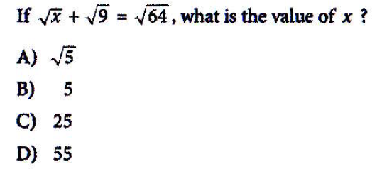**Tuesday 09/03: SAT No Calculator**

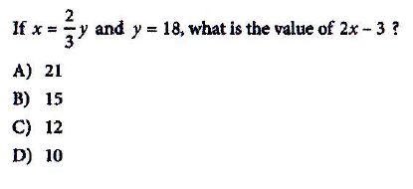**Wednesday 09/04: SAT No Calculator**

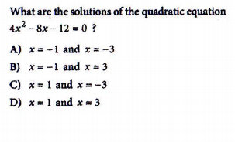**Thursday 09/05: SAT No Calculator**

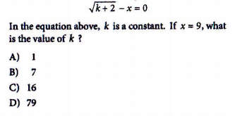**Friday 09/06: SAT No Calculator**