**Bellwork Sample Problem:** Factoring a Quadratic Function using the X-method

**Question:** Factor the following expression:

**2 $x^{2}+9x+10$**

* **Step1: Identify a, b and c**

The standard form of a quadratic function is a $x^{2}$**+b x+ c** a= b= c=

* **Step 2: Draw an X with the following info**

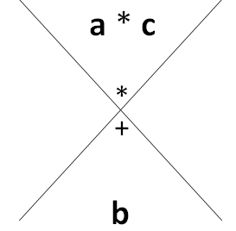

* **Step 3: Write the factors of a*c and find two numbers that add up to b**
* 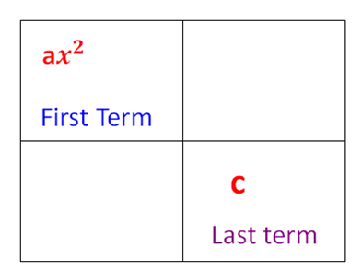**Step 4: Construct your box as follow**



*In the middle empty boxes, put the numbers you found in step 3 with an x next to each number*

* **Step 5:** Factor out the **GCF** from each 2 terms in the box, **vertically** and **horizontally**.



**Factored form: ( ) ( )**

***Note: Always use the sign of the closest number to the arrow***