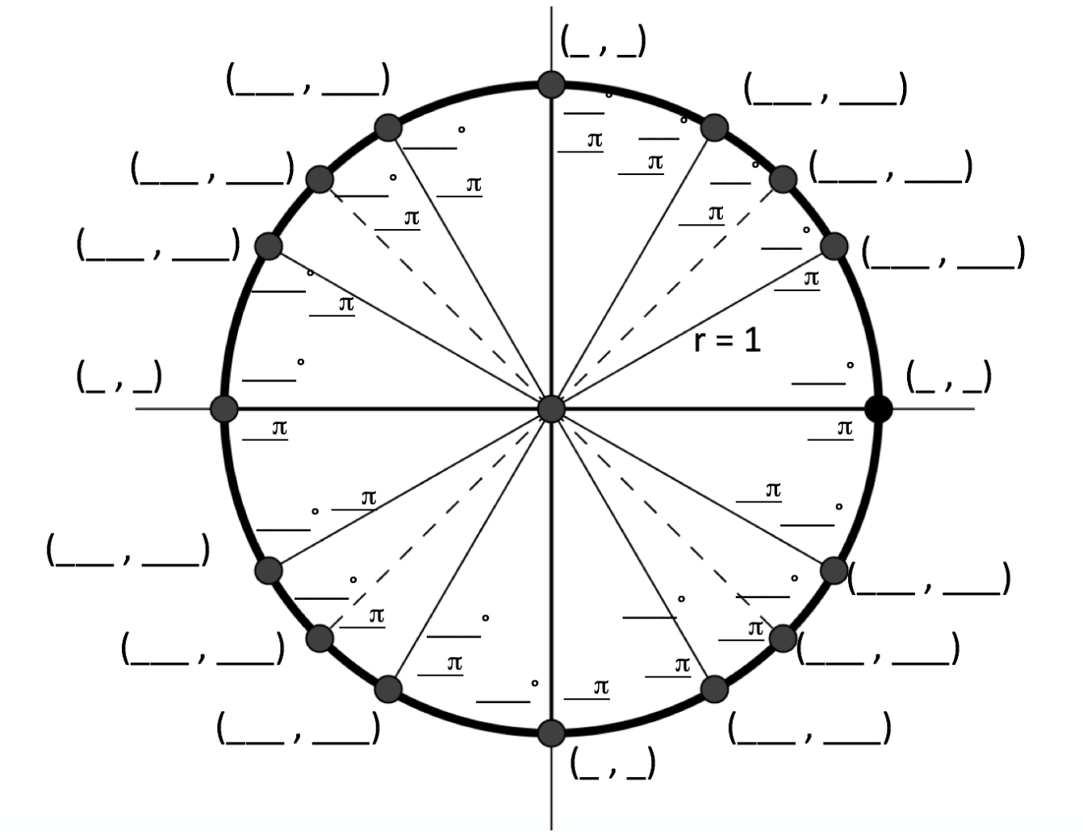



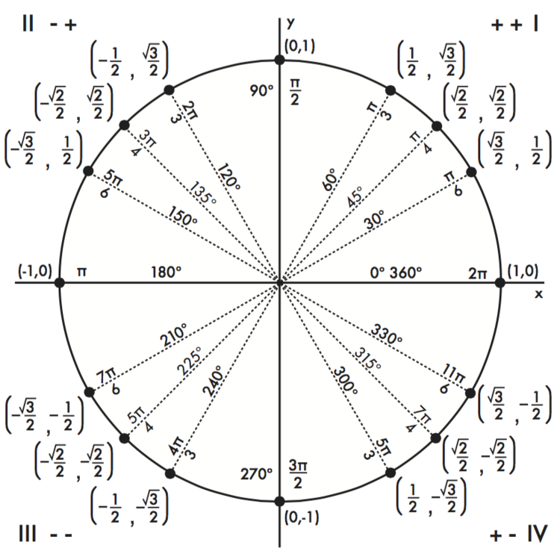

π

π

π

____°

____°

____°

____°

(___ , ___)

(___ , ___)

(___ , ___)

(___ , ___)

(___ , ___)

(___ , ___)

(___ , ___)

(___ , ___)

(___ , ___)

(___ , ___)

____°

r = 1

π

(_ , _)

___°

π

___°

π

π

____°

π

π

____°

___­_°

π

____°

(_ , _)

π

____°

π

(_ , _)

____°

π

π

____°

(___ , ___)

(___ , ___)

π

π

(_ , _)

___°

___°