**Sample SLOT Bell Work Week 2:** 09/11-09/15 ***Bellwork Tab worksheet 1***

**Name: Hour:**

*YOU MUST COPY DOWN THE ENTIRE QUESTION AND* ***SHOW YOUR WORK*** *TO RECEIVE CREDIT!*

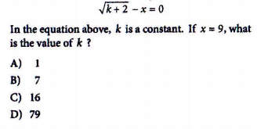**Monday: Date:_________ BW#1**

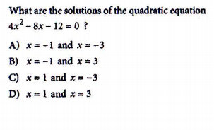**Tuesday: Date:__________ BW#2**

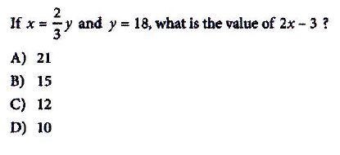**Wednesday: Date:_________ BW#3**

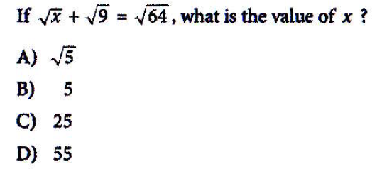**Thursday: Date:____________ BW#4**