**Unit 9 Mixed Practice**

1) What are the basic parts needed to form an electric circuit?

2) What is the position of the switch if the lights are turned ON? Explain.

3) What happens to the other light bulbs in a series circuit when one light bulb in a series circuit containing several light bulbs burns out?

4) What happens to the other light bulbs in a parallel circuit when one light bulb in a parallel circuit containing several light bulbs burns out?

5) What are two ways to increase the resistance of a wire? What are two ways to decrease the resistance of a wire?

6) According to Ohm’s Law, what is the relationship between current and resistance? What does this mean?

7) According to Ohm’s Law, what is the relationship between current and voltage? What does this mean?

8) 4 lamps with resistance of 10Ω, 14 Ω, 25 Ω, and 34 Ω are connected in series. What is their total resistance?

9) 4 lamps with resistance of 10Ω, 14 Ω, 25 Ω, and 34 Ω are connected in parallel. What is their total resistance?

10) A **series circuit** has 120 v source connected to 3 resistors: 45 Ω, 50 Ω, 70 Ω.

a) Draw a schematic diagram.

* b) Make a table for all the values V, I, R for each resistor and their totals.
* 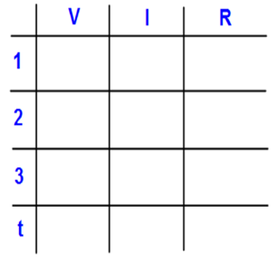
* c) What is the voltage drop at the 45 Ω.
* d) How does the current at the 45 Ω resistor compare to the current at the 70 Ω resistor?

11) A **parallel circuit** with a 120 v power source has 3 resistors: 10 Ω, 12 Ω, 22 Ω,

* a) Draw a schematic diagram.
* b) Make a table for all the values V, I, R for each resistor and their totals.
* 
* c) What is the current at the 22 Ω?
* d) How does the voltage at the 10 Ω resistor compare to the voltage at the 22 Ω resistor?