Energy and Cost Practice
Directions: show all work on a separate sheet of paper. Write the givens, show the formula, plug in numbers, calculate an answer, write with units, and circle your answer. Answers are in bold so you can check your own work. Assume 120 volts for anything plugged into a wall.
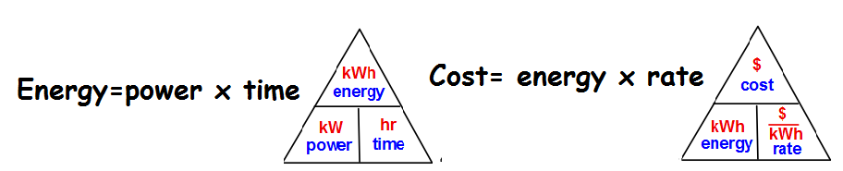

1) How much energy is used when a 120 kW appliance is used for 4 hours? (unit for energy is kW-hr) 480 kWh

2) How much energy (kWhr) is being used to run a 900 W microwave for 0.25 hours?
0.225 kWh

3) Your air conditioner uses 3500 W and runs for 8 hours in the day and DTE charges an average of $.08/kWh.

- How much does it cost per day to run that air conditioning? $2.24

- How much would it cost to run for a 31 day month? $69.44

4) Mrs. Olsen leaves her 800 W electric coffee maker on each day as she heads off to work at 7am because she likes to come home to a hot cup of coffee at 5pm.

- How much energy does she use for leaving the coffee maker during the day? 8 kwh

- If the electric company charges Mrs. Olsen $0.10 per kWh, how much does running the coffee maker all day cost her? $0.80

- What is the yearly cost to run the coffee maker (250 work days)? $200

Challenge:

5) If your oven takes 2500 Watts and uses 15 kWh of energy to cook a thanksgiving turkey, how much time was your oven running for? 6 hours

