**Chapter 37 Concept Brochure**

*Directions: Complete the following questions using the above sections.*

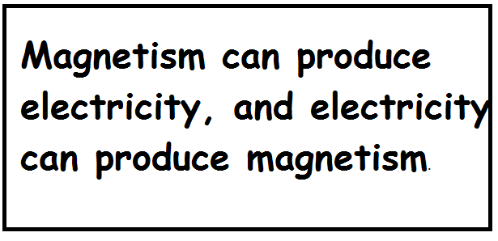

**Electromagnetic Induction (Section 37.1,37.2)**

**Draw the picture below and write a description in your own words:**

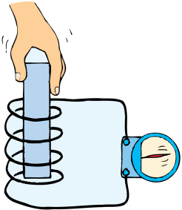

**Q1:** How can an electric current be induced (produced) in a wire?

**Q2:** How can voltage be induced in a wire with the help of a magnet?

**Q3:** What are 2 ways to increase the amount of voltage in a wire? What do we call this law?

**Generators and Motors (Section 37.3, 36.8 and extra resource)**

**Draw the picture below and write a description in your own words:**

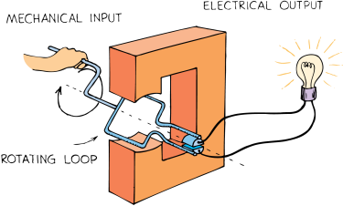 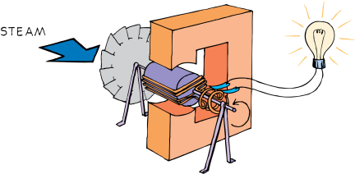

**Q4:** What are the 2 main parts of a generator? What kind of energy does it input and output?

**Q5:** The armature of a generator must rotate in order to produce voltage and current. What are some energy sources used to produce this rotation?

**Q6:** What are the 2 main parts of a motor? What kind of energy does it input and output?

**Transformers (37.5)**

**Draw the picture below and write a description in your own words:**

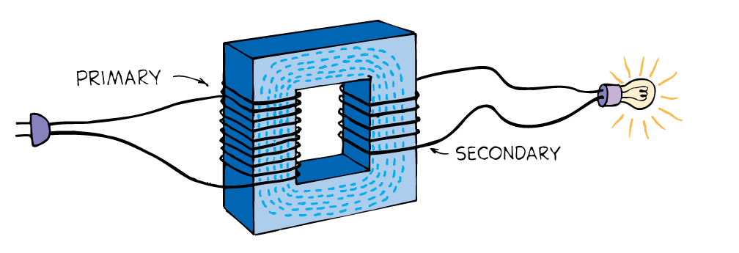

**Q7:** What is the purpose of a transformer?

**Q8:** What are the 3 parts of a transformer?

**Q9:** Where does the input of a transformer come from? Where does the output of a transformer come from?

**Q10:** What is the difference between a step-up transformer and a step-down transformer?

**Power Transmission (37.6)**

**Draw the picture below and write a description in your own words:**

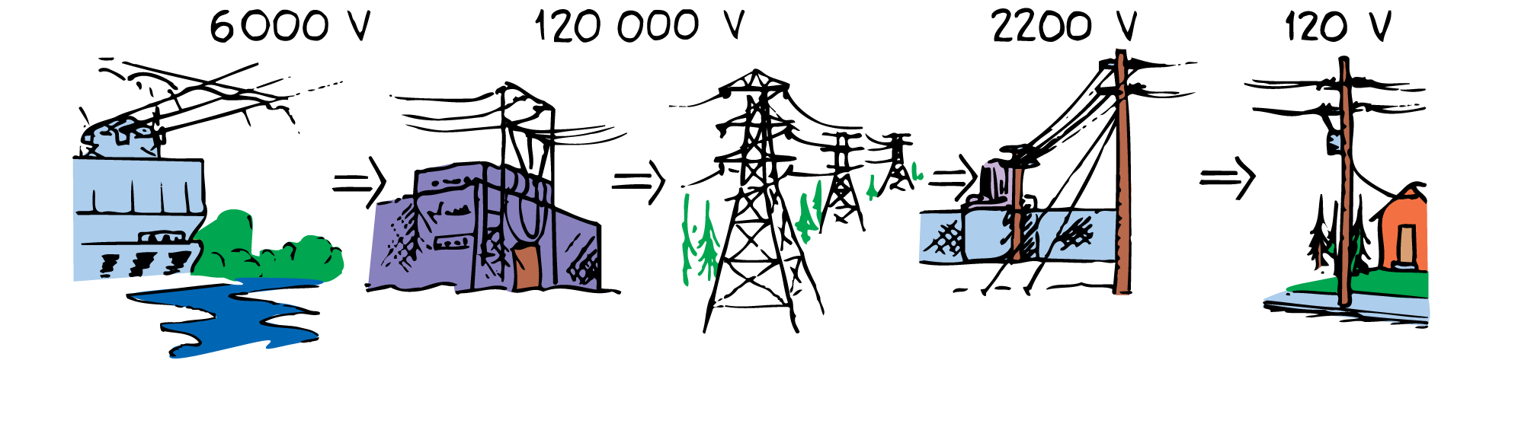

**Q11:** What is main reason why most electrical energy is sold today in the form of alternating current (AC) rather than direct current (DC)?

**Q12:** What is advantage of transmitting electric power long distances at high voltages?

**Q13:** Explain what happens to the power being carried from the power plants before it gets to our houses.