**Chapter 36 Magnetism Concept Question’s Brochure**

*Directions: Complete the following questions using the above sections.*

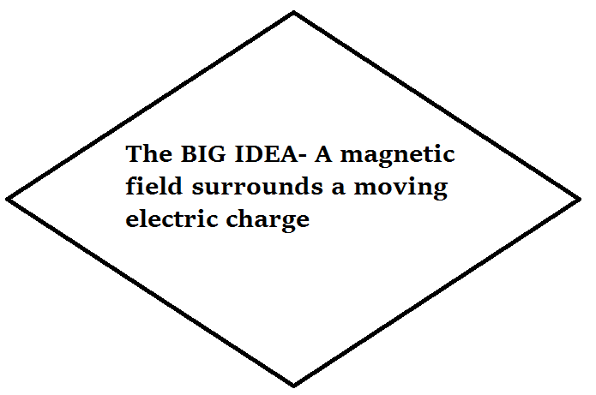

**1-Magnetic Poles (Section 36.1)**

**Draw the picture below and write a description in your own words:**

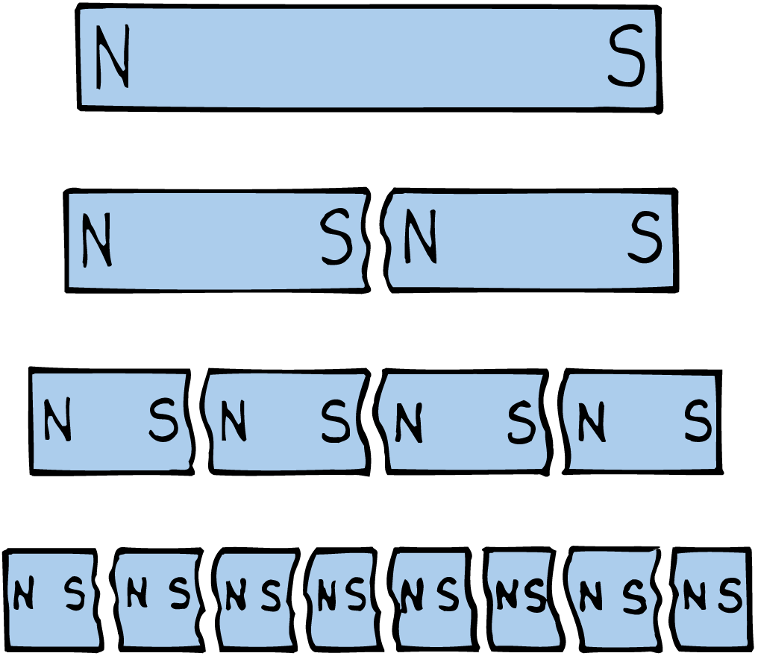

**Q1:** What are the 2 ends of a magnet called?

**Q2:** How are magnets similar to electric charges?

**Q3:** Can we separate the 2 ends of a magnet? Does every magnet have 2 ends?

**2-Magnetic Fields and the Nature of Magnetic Fields (Section 36.2 and 36.3)**

**Draw the picture below and write a description in your own words:**

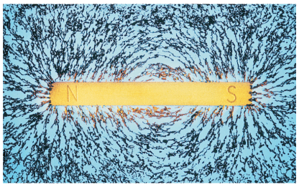

**Q4:** What is a magnetic field? What are magnetic field lines?

**Q5:** What is the direction of the magnetic field outside a magnet? How does how close they are mean?

**Q6:** How can spinning electrons work together or work against each other?

**Q7:** What is 1 reason why every object isn’t a magnet?

**3-Magnetic Domains (36.4)**

**Draw the picture below and write a description in your own words:**

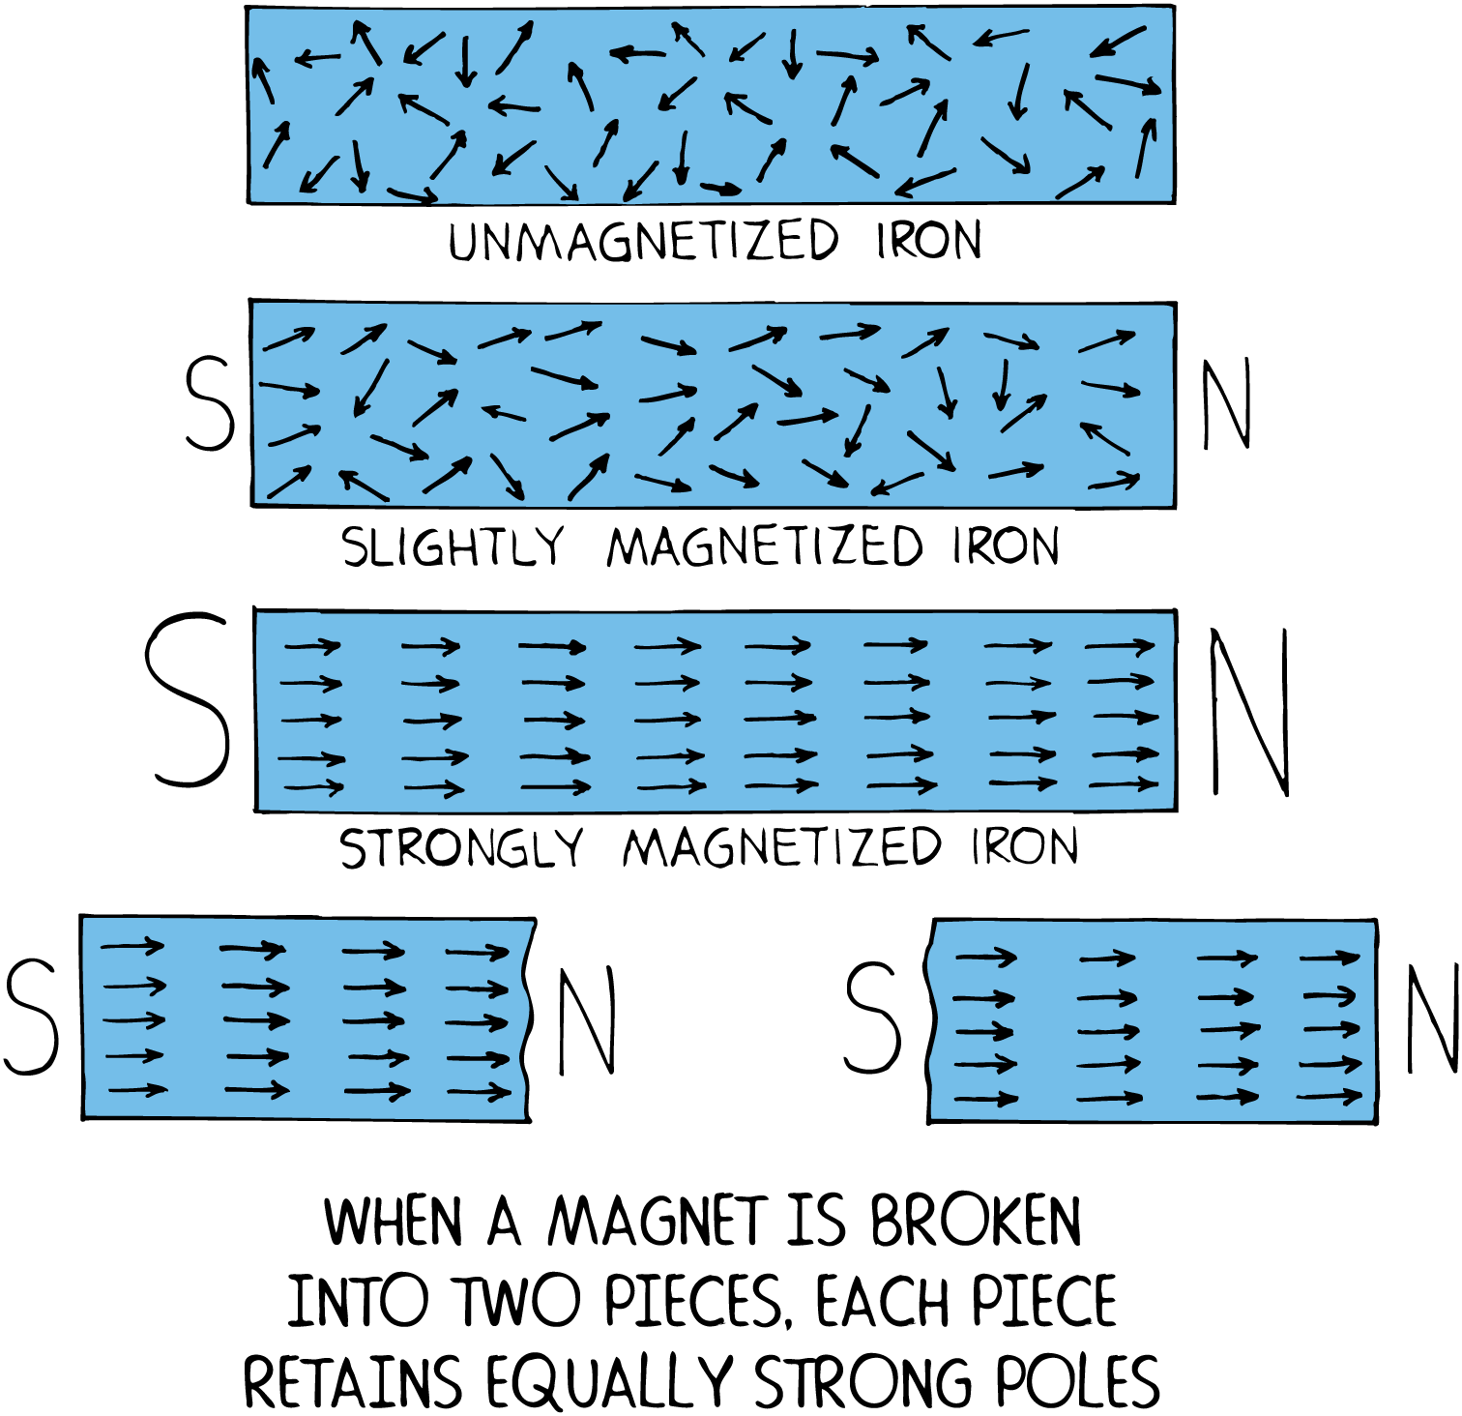

**Q8:** What is a magnetic domain?

**Q9:** What is the difference between an iron nail and an iron magnet?

**Q10:** What happens when you bring a potentially magnetic material near a magnet?

**4-Electric Currents and Magnetic Fields (36.5)**

**Draw the picture below and write a description in your own words:**

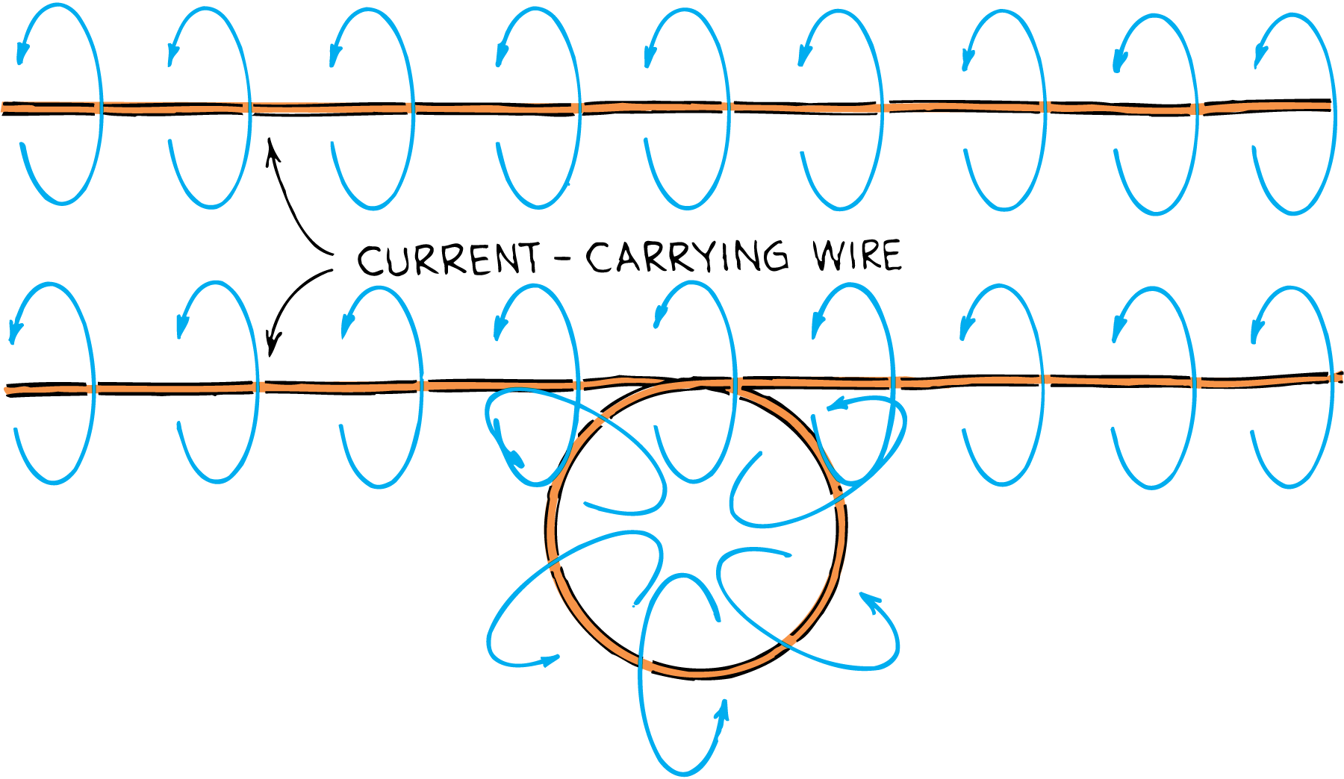

**Q11:** What types of fields are created by the motion of an electric charge (electric current)?

**Q12:** How can we increase the magnetic field intensity?

**Q13:** How is an electromagnet made (a temporary magnet)?