Metacognitive Chart
Key Concept | What I can explain about the idea before reading | Explanation from the reading  (explain where) | Real life examples of this idea in my life | Draw a Picture to Illustrate the Key Concept
Section 31.2

Diffraction

p.g. #625-627
Section 31.3

Interference

p.g. #628
Section 31.5

Iridescence

p.g. 631-632
Double Entry Journal
Problem | Solution
Section 31.2
- When does diffraction happen? Does the spreading become more or less pronounced for narrower openings?

- What is this spreading called?
- 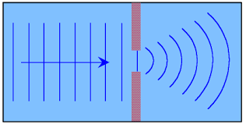

- Does it help or hurt radio reception for radio waves to be so big? Why?

- What kind of waves diffract easier?

Section 31.3
- Is it possible for a wave to make another wave smaller?...cancel it out? Defend your answer.

Section 31.5
- What is iridescence? What are some real world examples?

- When we see a colorful oil spot, do we see colors that constructively interfere, or destructively interfere? Why?

- Why is gasoline that is spilled on a wet surface so colorful?
Complete the following:
_________________ involves a change in direction of waves when they bounce off a barrier.
_________________ involves a change in direction of waves as they change mediums.
_________________ involves a change in direction of waves as they pass through an opening or around
an object.

