**Reflection and Refraction Simulation Lab**

1. Objective: To verify laws of reflection and refraction of light.
2. Procedure:
   1. Open the PhET Simulation on “Bending Light” <https://phet.colorado.edu/sims/html/bending-light/latest/bending-light_en.html>
   2. Click the tab “More Tools” that’s now on the bottom of the screen. Explore the sim and play around with its functionalities.

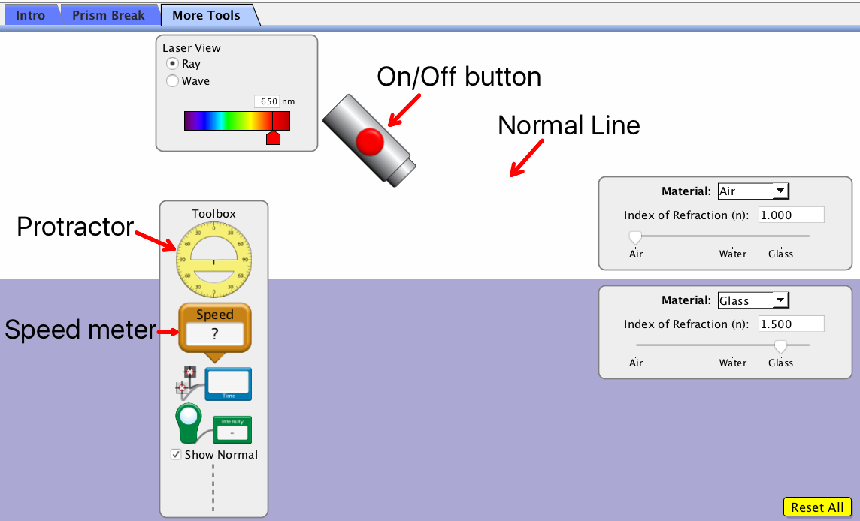

PART I. ***Definitions and Labeling***

* + 1. Turn on the light source. Refer to **Figure 1** below and identify the rays based on the definitions below:

1. Incident ray – is the light ray coming directly from the source.
2. Reflected ray – is the light ray that bounces back to the 1st material once it hits the boundary of the 2nd material. **What is another word for reflection?_________**
3. Refracted ray – is the light ray that passes through and bends towards/away the Normal line as it hits the 2nd material. **What is another word for refraction?___________________**

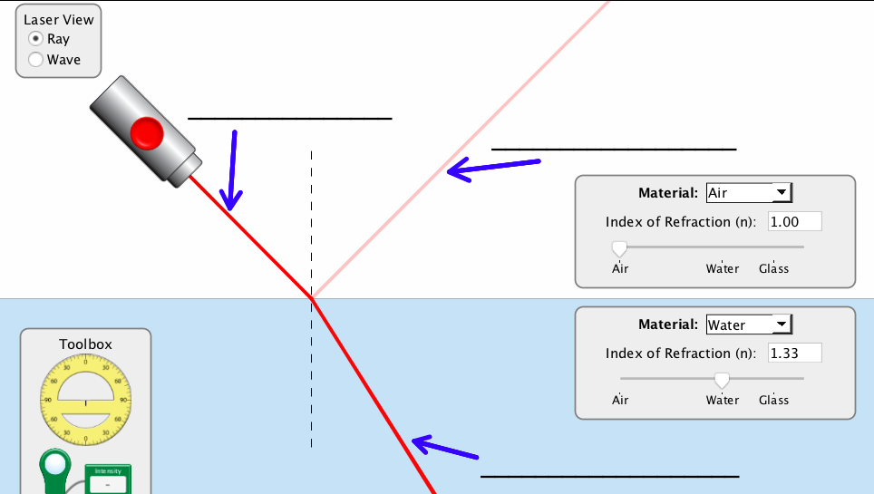

Figure 1. Light rays

PART II. ***Law of Reflection***

1. Place the center of the protractor at the intersection of the Normal line and the boundary of the two mediums.
2. Set top medium as **air** and bottom medium as **water**. Record the index of refraction of the two mediums in **table 1**.

Table 1. Index of Refraction of different medium

|  |  |  |
| --- | --- | --- |
| Material | Name | Index of refraction (*n*) |
| Top |  |  |
| Bottom |  |  |

1. Turn on the light source and move it so that the incident ray will have a reading of 300 from the Normal line.
2. Identify the angle of *reflected ray* from the Normal line and record it in **Table #2.**
3. Now, move the light source to change the angle of incidence of your own choice. Record the angle of incident ray and reflected ray in Table #2 along reading #2.

Table 2. Angle of reflected ray

|  |  |  |
| --- | --- | --- |
| Readings | Angle of incident ray | Angle of reflected ray |
| 1 | 300 |  |
| 2 |  |  |

1. **From Table #2, what do you notice about the angle of incident ray and angle of reflected ray from the two (2) readings?** (complete sentence) **________________________________________________________________________________________________.**
2. **The Law of Reflection states that the angle of incident ray is ________________ to the angle of the _______________________.**

PART III. ***Speed of light (c) through different mediums***

1. Set the top medium as air and the bottom medium as water.
2. Turn on the light source and move it so that the incident ray will have a reading of 300 from the Normal line.
3. Place the speed tool on the incident and reflected ray in the air. Record the value of the speed of light (c) in table 3 (next page). A value of 1.00 c is equivalent to 3 x 108 m/s.
4. Place the speed tool on the refracted ray in the water. Record the value of the speed of light (c) in water in table 3.
5. Keep the top medium set as air and change the bottom medium to glass, then mystery A, mystery B and record the value of the speed of light (c) in table 3.

Table 3. Speed of light (c) in various mediums.

|  |  |
| --- | --- |
| Material | Speed of light (c) |
| Air |  |
| Water |  |
| Glass |  |
| Mystery A |  |
| Mystery B |  |

1. **Which type of medium does light travel the fastest in? The slowest in? Why do you think this is?**

**________________________________________________________________________________________________.**

1. **Do you think the mystery A medium is a solid or a liquid? What evidence do you have to support this claim?**

**________________________________________________________________________________________________.**

1. **Do you think the mystery B medium is a solid or a liquid? What evidence do you have to support this claim?**

PART IV. ***Bending of light towards/away from the Normal:***

1. Set the top material as air and the bottom material as water.
2. Turn on the light source and move it so that the incident ray will have a reading of 300 from the Normal line.
3. **How does the refracted ray bend relative to the normal when it crosses the boundary from air into water? Draw the rays below:**

**_____________________________________________________________________________________________**

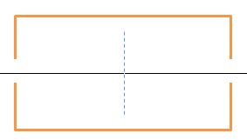

1. Set the top material as air and the bottom material as glass.
2. Turn on the light source and move it so that the incident ray will have a reading of 300 from the Normal line.
3. **How does the refracted ray bend relative to the normal when it crosses the boundary from air into glass? Draw the rays below:**

**_____________________________________________________________________________________________**



1. Set the top material as water and the bottom material as air.
2. Turn on the light source and move it so that the incident ray will have a reading of 300 from the Normal line.
3. **How does the refracted ray bend relative to the normal when it crosses the boundary from water into air? Draw the rays below:**

**_____________________________________________________________________________________________**



1. Set the top material as glass and the bottom material as air.
2. Turn on the light source and move it so that the incident ray will have a reading of 300 from the Normal line.
3. **How does the refracted ray bend relative to the normal when it crosses the boundary from glass into air? Draw the rays below:**

**_____________________________________________________________________________________________**



1. Set the top material as air and the bottom material as air.
2. Turn on the light source and move it so that the incident ray will have a reading of 300 from the Normal line.
3. **Why doesn’t the ray bend as it crosses between the top and bottom half?**

_____________________________________________________________________________________________

***Part V - Analysis:***

Based on your data, what patterns do you observe? Write at least **three** summary statements.

_________________________________________________________________________________________________________________________________________________________________________________________________________________________________________________________________________________________________________________________________________________________________________________________________________________________________________________________________________________

_____________________________________________________________________________________________

_____________________________________________________________________________________________