**Station 1- Finding the Net Force “**ΣF”

1. Consider a force of 30 N and 40 N.
   1. If they are applied during a game of tug of war, which force would win? By how much?
   2. What is the biggest force I could get from them? Smallest force?
2. 100 N Left, 50 N Right.
   1. What is the net force? Identify the C, E, R
   2. Is the net force balanced or unbalanced?
3. 200 N East, 125 N East
   1. What is the net force? Identify the C, E, R
   2. Is the net force balanced or unbalanced?
4. 30 N up, 30 N down
   1. What is the net force? Identify the C, E, R
   2. Is the net force balanced or unbalanced?
5. During 3rd hour Amira was a beast. She resisted the forces applied by 5 people in her class all at once. They applied a total force of 95 N to the right and Amira did not move.
   1. What is the net force? Identify the C, E, R
   2. Is the net force balanced or unbalanced?
6. Find the net force acting on a fridge if the applied forces are 378.4 N, west and 401.3 N, east.
   1. What is the net force? Identify the C, E, R
   2. Is the net force balanced or unbalanced?
7. Hussein is mowing the lawn with an applied force of 8 N and a force due to friction of 6 N between the grass and the lawn mower.
   1. What is the net force? Identify the C, E, R
   2. Is the net force balanced or unbalanced?
8. Create your own net force/diagram problems and solve.

**Station 2- Short Answer**

Directions: Answer each of the following questions using complete sentences.

1. What is the net force of an object in mechanical equilibrium?
2. Does a net force of zero mean no movement? Explain.
3. How do you recognize when an object is in and out of mechanical equilibrium?
4. Can an object be in mechanical equilibrium with only one force acting on it? Explain.
5. What is the difference between static equilibrium and dynamic equilibrium?
6. What two forces act on a book resting on a table? Draw and label a force diagram to represent this.
7. Draw and label a force diagram of 4 balanced forces acting on a car moving in equilibrium.
8. What is the equilibrium rule? How can we represent it mathematically?
9. What is the difference between a vector quantity and a scalar quantity? Is force considered a vector or scalar quantity? How do you know?
10. An airplane flies horizontally at constant speed in a straight-line direction. Its state of motion is unchanging. In other words, it is in equilibrium. Two horizontal forces act on the plane. One is the thrust of the propeller that pulls it forward. The other is the force of air resistance (air friction) that acts in the opposite direction. Which force is greater?

**Station 3- Multiple Choice**

Directions: Choose the correct claim for each m.c. question and provide reasoning to support your claim.

1. When you hold a rock in your hand at rest, the forces on the rock _______:
2. are mainly due to gravity.
3. are mainly due to the upward push of your hand.
4. cancel to zero.
5. don’t act unless the rock is dropped.

**2.** A 10-Newton force and a 15-Newton force are acting from a single point in opposite directions. What additional force must be added to produce equilibrium?

A) 5 N acting in the same direction as the 10-N force

B) 5 N acting in the same direction as the 15-N force

C) 10 N acting in the same direction as the 10-N force

D) 25 N acting in the same direction as the 15-N force

**3.** Burl and Paul have combined weights of 1300 N. The tensions in the supporting ropes that support the scaffold they stand on add to 1700 N. The weight of the scaffold itself must be :

* 1. 400 N.
  2. 500 N.
  3. 600 N.
  4. 3000 N.

**4.** Harry gives his little sister a piggyback ride. Harry weighs 400 N and his little sister weighs 200 N. The support force supplied by the floor must be:

1. 200 N.
2. 400 N.
3. 600 N.
4. more than 600 N.

**5.** When a desk is horizontally pushed across a floor at a steady speed in a straight-line direction, the amount of friction acting on the desk is:

1. less than the pushing force.
2. equal to the pushing force.
3. greater than the pushing force.
4. dependent on the speed of the sliding crate.

**6.** When Nellie hangs at rest by a pair of ropes, the tensions in the ropes:

* 1. always equal her weight.
  2. always equal half her weight.
  3. depend on the angle of the ropes to the vertical.
  4. are twice her weight.

**7.** What is the maximum resultant possible between a 2-N and an 8-N force?

a. 8 N

b. 10 N

c. 6 N

d. 0 N

**8.** What is the minimum resultant possible between a 2-N and an 8-N force?

a. 8 N

b. 10 N

c. 6 N

d. 0 N

**9.** A boy whose weight is 400 N hangs from the middle of a bar supported by two vertical strands of rope. What is the tension in each strand?

* 1. 0 N
  2. 400 N
  3. 800 N
  4. 200 N

**10.** Create a multiple choice question and circle the correct claim.

Station 4- Talking to the Visual

1. Use the figure below to answer questions a, b and c:

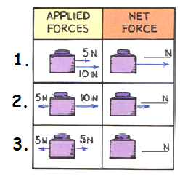

* 1. Fill in the blanks for the net force using the above diagram.
  2. Which one(s) will change the motion of the object?
  3. Which one(s) will NOT change the motion of the object?
  4. Which of the three pictures above shows the object in equilibrium?

1. Use the figure below to answer questions a, b, and c:



* 1. How many forces are acting on the rocks? Draw and label each force using a force diagram.
  2. What is the net force acting on rocks? How do you know this?
  3. What can you apply to cause a change in motion?

1. Use the figure below to answer questions a, b, and c:

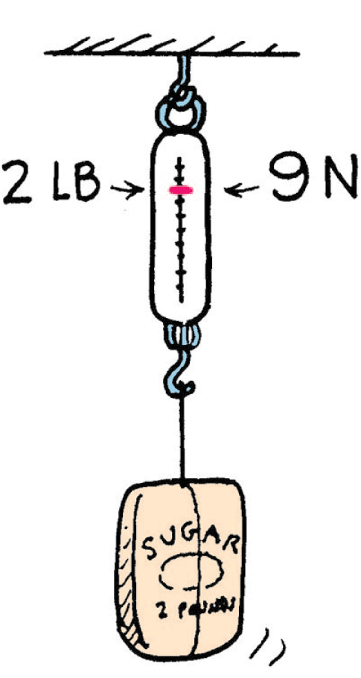

* 1. How many forces are acting on the bag of sugar? Name each force.
  2. What direction does each type of force act?
  3. Are the 2 forces balanced or unbalanced?

1. Use the figure below to answer questions a, b, c, d and e.

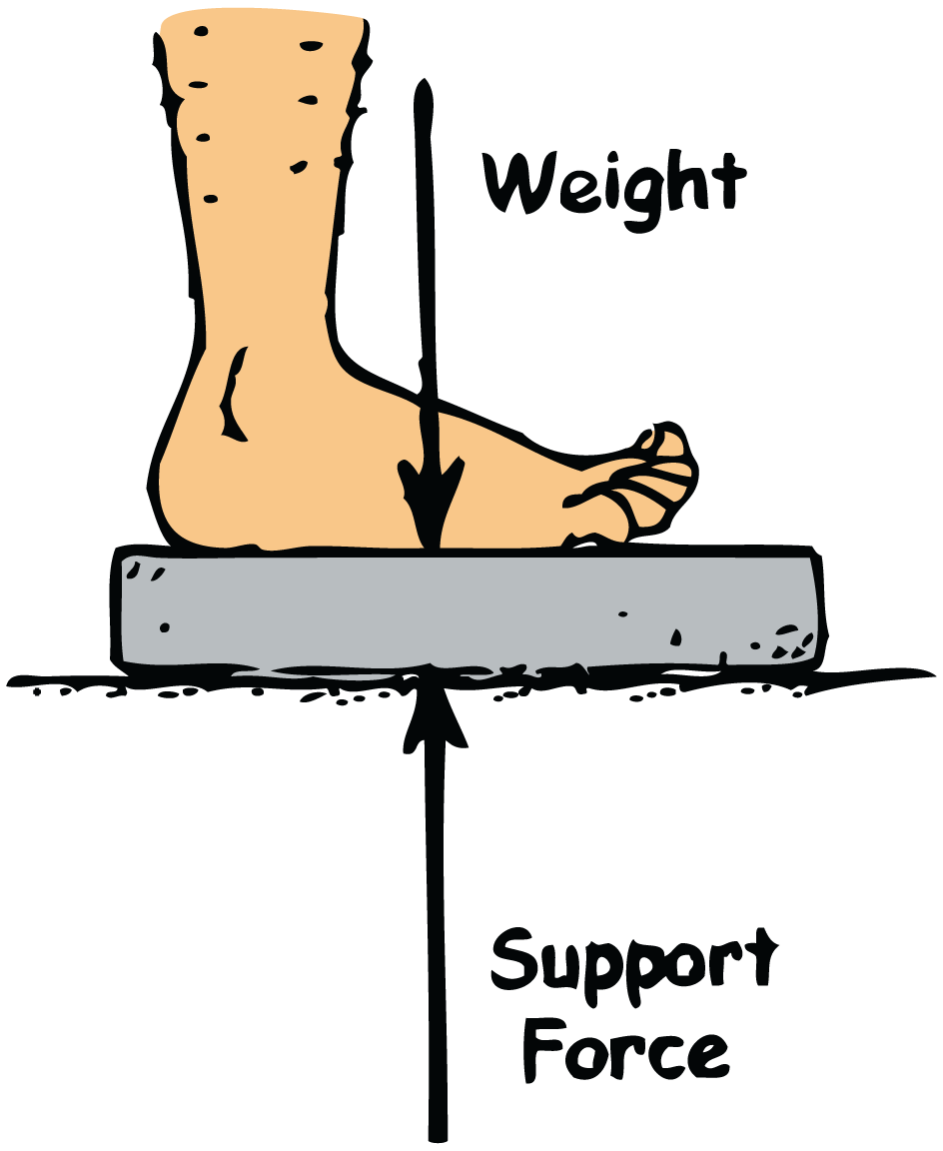

* 1. Weight is the force due to __________.
  2. What’s the everyday unit for weight? What is the SI unit for weight?
  3. What is the net force on a bathroom scale when a 110-pound person stands on it?
  4. Does the scale read the support force or the net force?
  5. Suppose you stand on two bathroom scales with your weight of 110 pounds evenly distributed between the two scales. What is the reading on each of the scales? What happens when you stand with more of your weight on one foot than the other?

1. Use the figure below to answer questions a, b, c, and d.

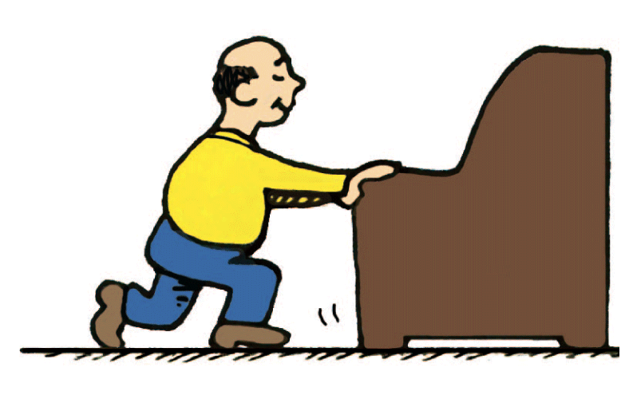

* 1. How can the moving desk be in a state of equilibrium?
  2. What are the 4 balanced forces acting on the desk?
  3. Which pairs of forces are acting equal and opposite to each other?
  4. What type of mechanical equilibrium is the desk in if it’s moving?