Name of animal | Picture of animal | Key words related to the animal | 2-3 sentences describing the appearance and qualities of the animal.
EXAMPLE:  Frog | 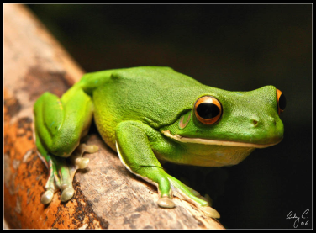 | Camouflage, creature, protect, preys, amphibian  species | Frogs are amphibians that live in the rainforest. Some frogs change color to blend with the nature for protection.
Report on Creatures of the Rain Forest

