**AOW 8:** History of Halloween

Halloween falls on October 31st each year in North America and other parts of the world. What do you know about Halloween? Do you celebrate it in your country? Here is a little history about Halloween.

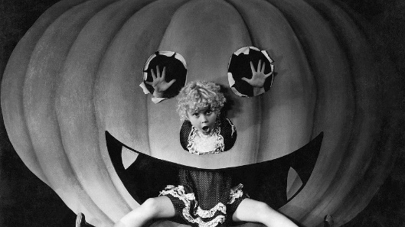

Like many other holidays, Halloween has **evolved** and changed throughout history. Over 2,000 years ago people called the Celts lived in what is now Ireland, the UK, and parts of Northern France. November 1 was their New Year's Day. They believed that the night before the New Year (October 31) was a time when the living and the dead came together.

More than a thousand years ago the Christian church named November 1 All Saints Day. This was a special day to honor the saints and other people who died for their religion. The night before was called Halloween.

Like the Celts, the Europeans of that time also believed that the **spirits** of the dead would visit the earth on Halloween. They worried that **evil** spirits would cause problems or hurt them. So on that night people wore costumes that looked like ghosts. They thought if they dressed like that, the spirits would think they were also dead and not harm them.

The **tradition** of Halloween was carried to America by European immigrants. Some of the traditions changed a little, though. In America, pumpkins were common. So people began putting candles inside them and using them as **lanterns.** That is why you see Jack 'o lanterns today.

[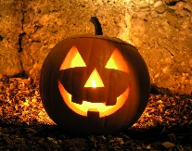](https://www.google.com/url?sa=i&rct=j&q=&esrc=s&source=imgres&cd=&cad=rja&uact=8&ved=0ahUKEwicmPTqspfXAhWHyIMKHXpnCVoQjRwIBw&url=https://wonderopolis.org/wonder/what-is-a-jack-o-lantern&psig=AOvVaw1vVJtQC2s7LNibuwKO4TmI&ust=1509420272295832)

*Happy Halloween!*

***Instructions***

**Day One (Monday):** Watch a short clip about the article.Read the article, then find the meanings of the underlined words and circle the clues.

**Day Two (Tuesday):**Re-read the article, highlight the main idea in yellow and underline two supporting details.

**Day Three (Wednesday*):***

***Identify 7 verbs in the simple past* in the article.**

_______ _____________ __________ ______________ ____________ ___________ _____________

***Classify the verbs into regular and irregular verbs:***

Regular past verbs: ________ __________ ____________ ___________

Irregular past verbs:________ __________ ____________ ___________

**Day Four: (Thursday)**

Questions:

1. The Celts thought the spirits of dead people returned to the earth on October 31st.

True

False

2. The Celts created Halloween.

True

False

3. Halloween is on October 31st.

True

False

4. A thousand years ago Europeans wore costumes to get candy.

True

False

5. Americans carve apples to use as lanterns.

True

False

6. Today Halloween is especially for children.

True

False

**Day Five: (Friday)**

Halloween is a spooky time of year when people share scary stories for fun! Write about a scary story you have encountered, heard or read about with your classmates.

____________________________________________________________________________________________________________________________________________________________________________________________________________________________________________________________________________________________________________________________________________________________________________________________________________________________________________________________________________________________________________________________________________________________________________________________________________________________________________________________________________________________________________________________________________________________________________________________________________________________________________________________________________________________________________________________________________________________________________________________________________