**Unit 4 Projects –EL1B**

1. *Create a large poster about compound words: Title: Compound Words*

-Define compound words

-Create 2 categories of **compound words,** **Things at School** and **things in the house.**

-Use each compound word in a sentence.

|  |  |
| --- | --- |
| **Definition:** A compound word is….. | **Things at school:**   1. **Notebook:** The student’s note book was empty. |
| **Things in the house:**  **1-Armchair:** My grandmother’s armchair is very comfortable. | **Pictures**  Image result for armchair **Armchair** |

1. *Create a poster about homophones: Title: Homophones*

-The poster should be divided into three columns

|  |  |  |
| --- | --- | --- |
| **Homophones** | Pictures | Sentences |
| I  EYE | Image result for person pointing to himself  Image result for eye | I like to go to beach by myself.  Jane’s eyes are as blue as the sky. |

1. *Create a poster about Homographs: Title: Homographs*

-The poster should be divided into three columns

|  |  |  |
| --- | --- | --- |
| **Homographs** | Pictures | Sentences |
| Bat  Bat | Image result for bat  Image result for baseball bat | The bat flew around In the night sky.  I hit the ball with the baseball bat. |

4-*Create a poster about Similes: Title: Similes*

-The poster should have a definition of similes, examples of similes with pictures

-The poster should be in the following manner:

|  |  |  |
| --- | --- | --- |
| Definition of Similes: | | |
| Picture One | Picture Two | Simile |
| Image result for tall man Tall man | Image result for tall tree Tall Tree | The man is **as tall as** the tree. |

5-*My Dream Room- Sensory Detail Poster: Title: Sensory Details poster*

* Create a poster with cut out magazine papers about your dream room.
* Label all the different furniture in the room.
* Then write sentences describing some sensory details. For example:

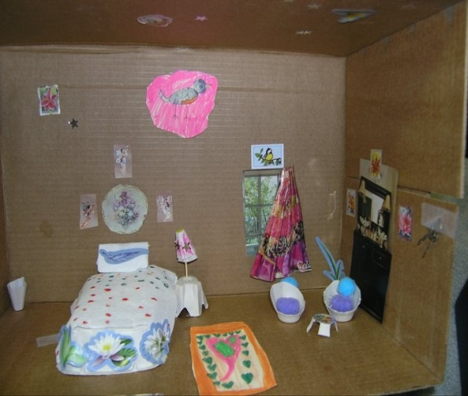

1. **I see a small orange rug next to the bed.**
2. **The room is as noisy as a rock concert.**
3. **The room smells like the scent of a blooming bouquet of flowers.**