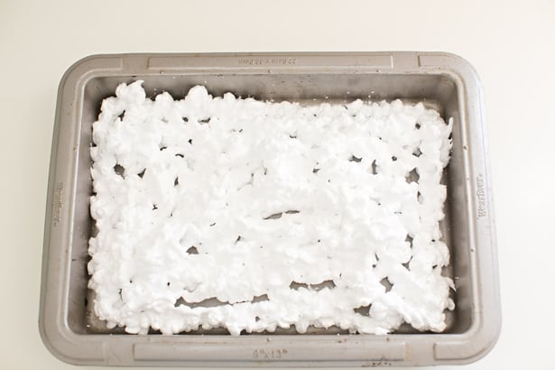

Fill your pan with shaving cream

Put paint onto the shaving cream in the form of your picture. This is an example of a rainbow.

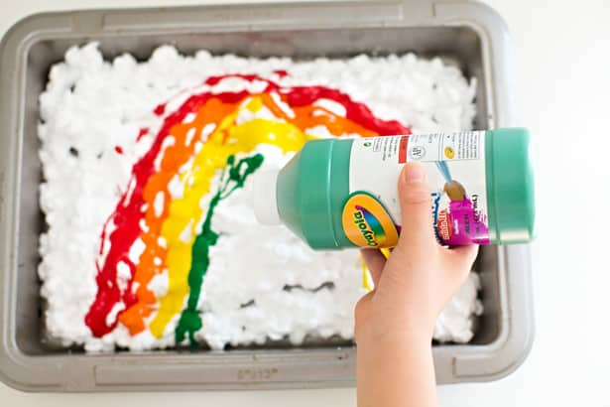

**Trim your watercolor paper to fit inside the pan if necessary. Lay it down flat on top of your rainbow, pressing firmly but gently on all sides.**

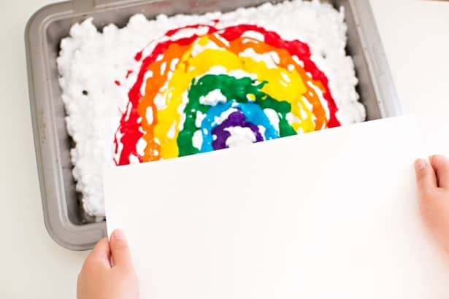 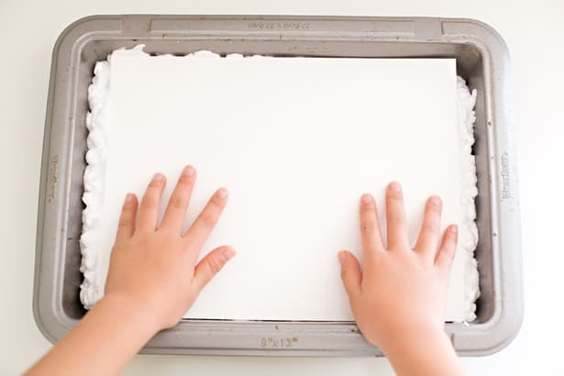

Lift off paper to see your art!

