This item is a paid digital download from my Teachers



Pay Teachers store: [https://](https://www.teacherspayteachers.com/Store/The-Sped-Teacher)

[www.teacherspayteachers.com/Store/The-Sped-Teacher](https://www.teacherspayteachers.com/Store/The-Sped-Teacher)  As such, it is for use in one classroom only. This item is also bound by copyright laws and redistributing, edit-

ing, selling, or posting this item (or any part thereof) on the Internet are all strictly prohibited without first

gaining permission from the author. Violations are subject to the penalties of the Digital Millennium Copyright Act. Please contact me if you wish to be granted special permissions!

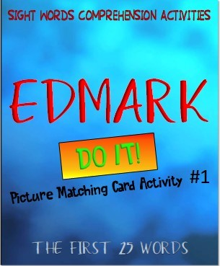

Feel free to check out more materials



at The SPED Teacher



-

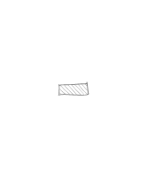

designed for



Special Education and the Life Skills



classroom.

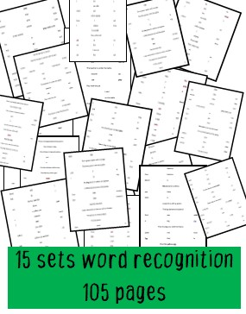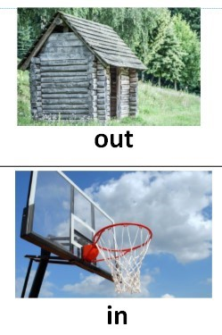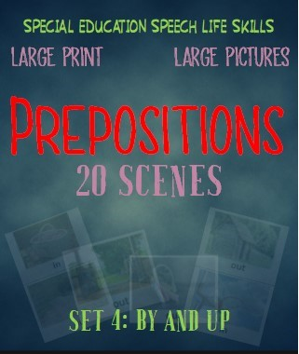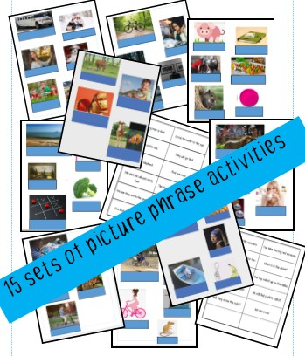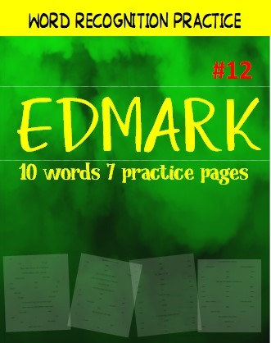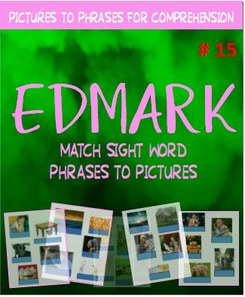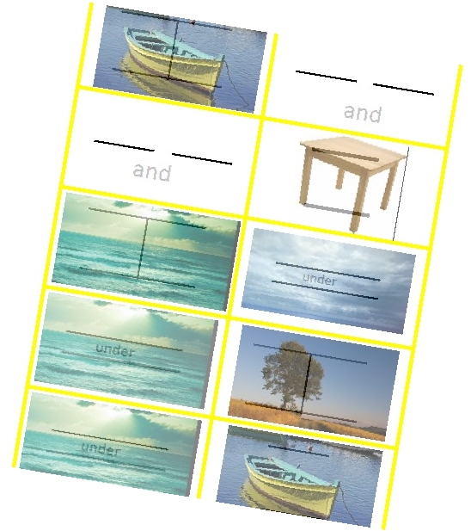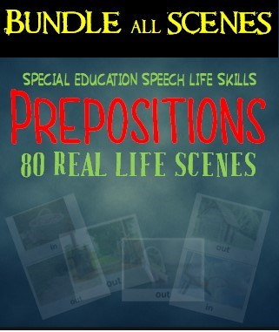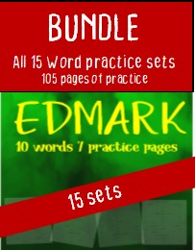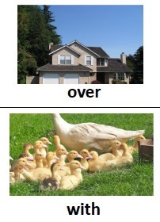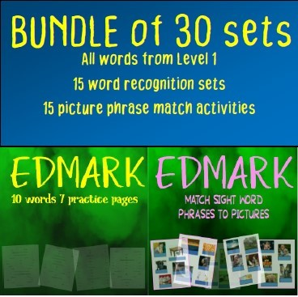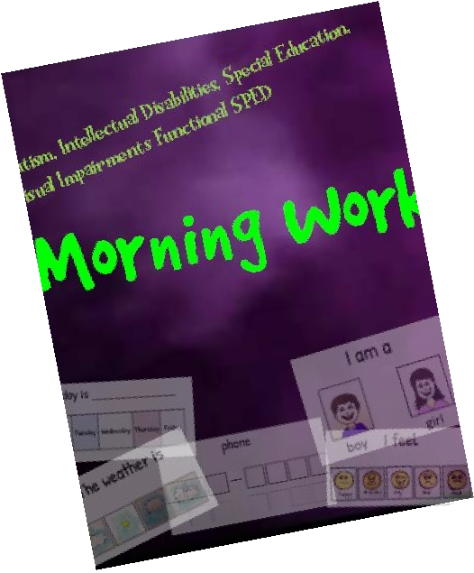

3 pages are included for each activity. The first two pages are where the phrases are to be placed, and the next page is the phrases themselves.

There are a number of ways this activity may be presented.

Laminating is recommended for whatever presentation you choose.

Take the two picture pages and place them in a file folder for a “file – folder” activity. File folder activities work well beside the picturephrase cards of the Edmark program: they can be stored easily in the same way.

Large board or construction paper may serve as a background for both pages. Presented this way, the activity does not need to be folded; it would present as large cards or posters for matching.

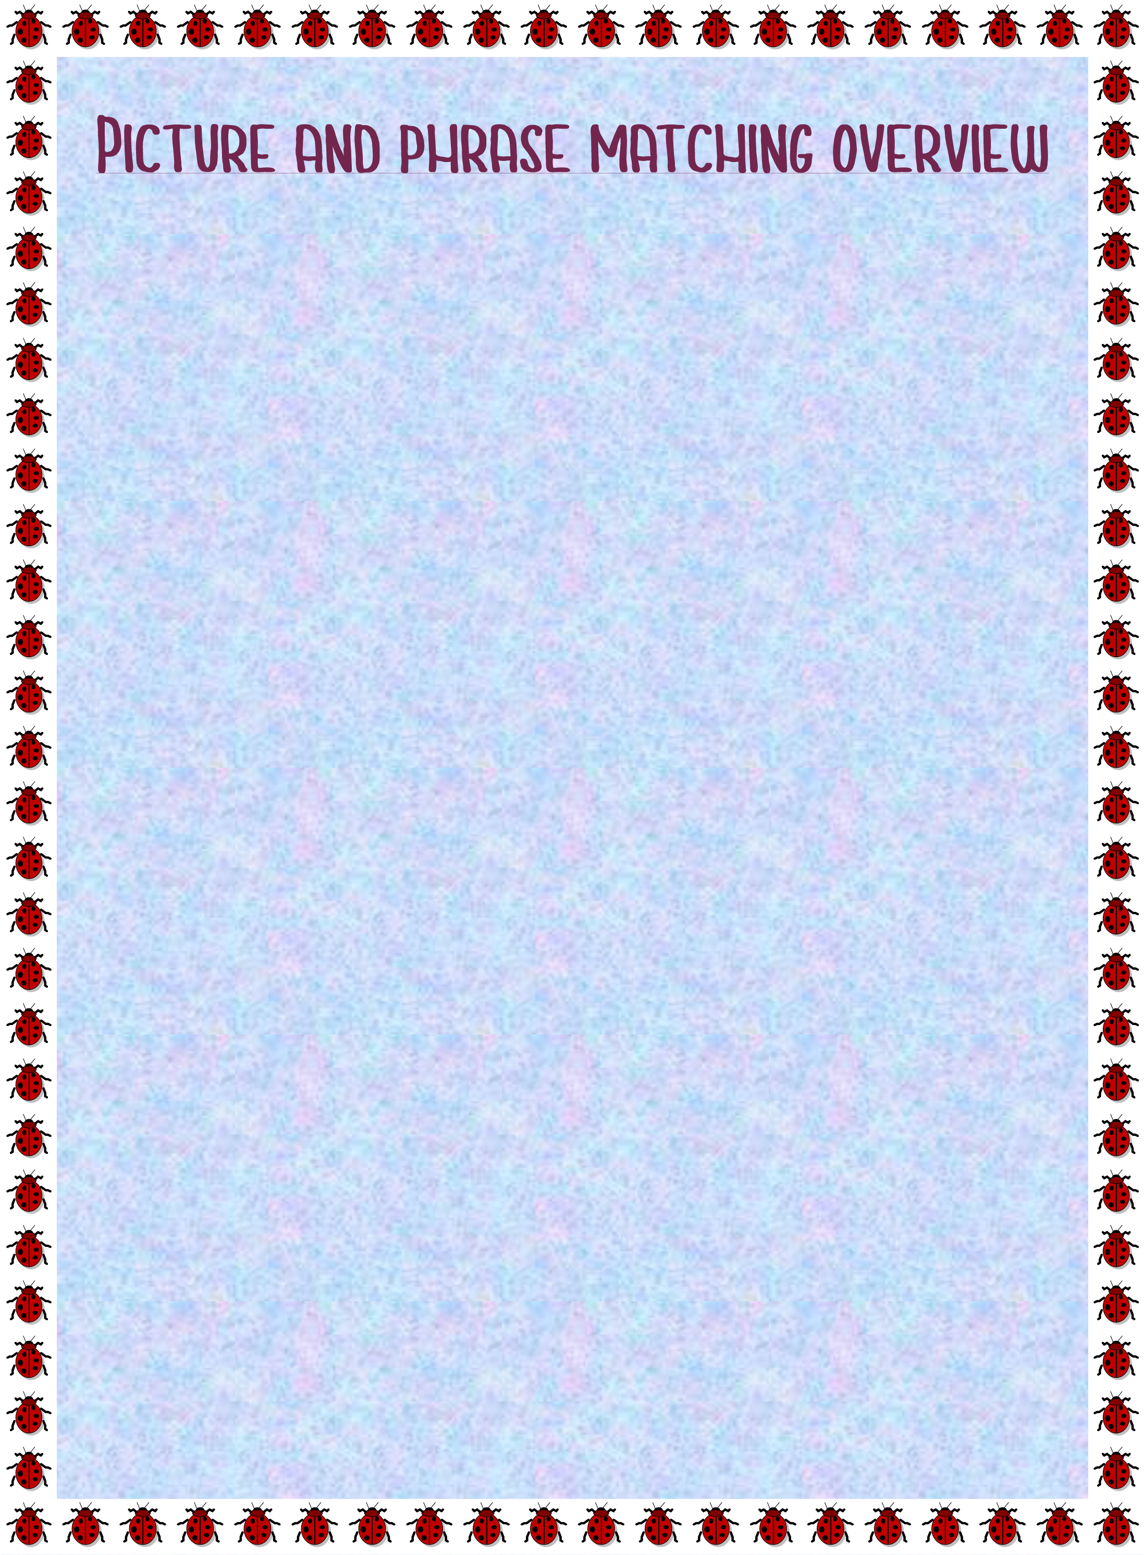Reduce the number of pictures. Don’t use both pages of pictures if this means too many phrases for your student (s.) Instead, these can be split into one page as a single activity or even made into individual task cards.

The blue squares under each picture denote the areas that the phrases are to be placed. They can be free of adhesives, as in the other picture phrase cards, or they can be attached with velcro. The cards them-

selves, on page 4 of this download, are to be cut individually, so that the students can match them with the pictures.

|  |  |
| --- | --- |
|  |  |
|  |
|  |
| |  | | --- | |  | |  | |

|  |
| --- |
|  |
|  |

|  |
| --- |
|  |
|  |
|  |

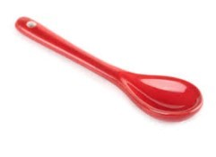

|  |
| --- |
|  |
|  |

|  |  |
| --- | --- |
| The egg is yellow. | Find the yellow banana. |
| I see the big cow with a chicken. | red ball with red apple |
| pencil and spoon | my big green car |
| my little yellow pencil | I find my ball. |
| Find a big red spoon. | the banana |
| girl and horse |  |

|  |
| --- |
|  |
|  |

|  |  |  |  |
| --- | --- | --- | --- |
|  | |  | | --- | |  | |  | |
|  |
| |  | | --- | |  | |  | |

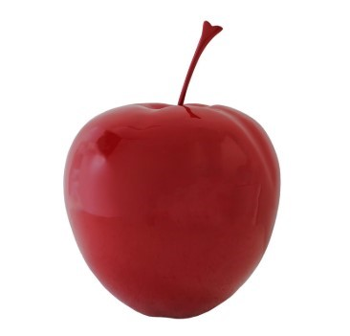

|  |  |  |  |  |  |  |  |
| --- | --- | --- | --- | --- | --- | --- | --- |
| |  | | --- | |  | |  | |  | |  | | |  | | --- | |  | |  | |
|  |
|  |

|  |  |
| --- | --- |
| the boy and girl | girl with airplane |
| a yellow chicken | chicken in a box |
| Put the apple in a box | Put the ball in a box |
| small green car | little girl |
| girl with a apple |  |