BUILD ORGANIZATION, PLANNING, & TIME MANAGEMENT SKILLS

FOOD LAB

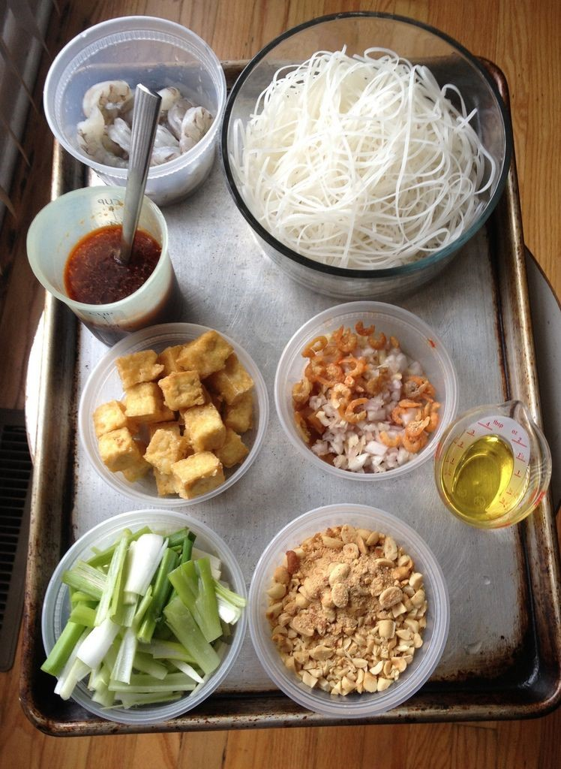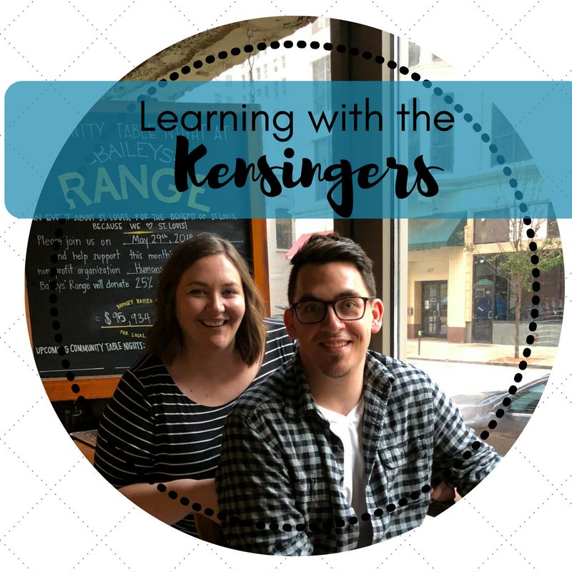

PLANNING

A student guide to prepare for & evaluate food labs

By Katie @ Learning with the Kensingers

BUILD ORGANIZATION, PLANNING, & TIME MANAGEMENT SKILLS

Food labs

# COLLABORATION TIME MANAGEMENT

* GRADES 6-12
* EASY TO IMPLEMENT
* NEED HELP ENSURING THAT YOUR STUDENTS READ THE RECIPE? WANT TO ADD TECHNICAL READING AND WRITING TO YOUR FOOD LABS?
* THIS FOOD LAB PLANNING SHEET REQUIRES DETAILED PLANNING REGARDING THE RECIPE DIRECTIONS AND COLLABORATION BETWEEN GROUP MEMBERS
* FOODS, NUTRITION AND WELLNESS, CULINARY, INTRO TO FCS, ETC

This product was created by Katie Kensinger– Learning with the Kensingers.

This work is not to be copied, resold, or distributed. If you wish to share this with your colleagues or department, please purchase multiple licenses. Thank you for understanding!



LISTENING SKILLS

THINKING SKILLS

ORGANIZATION SKILLS

I hope you enjoy the product. If you have any questions, please email me at kckensinger@gmail.com. Have a great day!

Katie Kensinger, Learning with the Kensingers

By Katie @ Learning with the Kensingers

Name_____________________________________________________ Food Lab_____________________

## Lab Planning Sheet

*Directions: Utilize the recipe to complete the following and prepare for your food lab.*

Mise En Place​ F​ rench term; literally means "set in **p**​ **lace**​ ," and it refers to having all your ingredients prepped and ready to go before you start cooking.

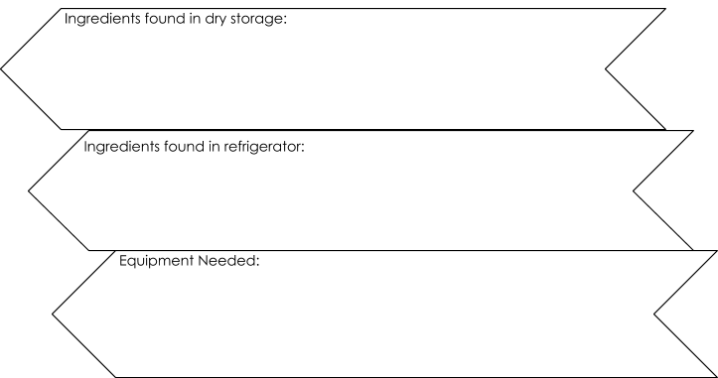

Cooking Terminology and Definition

______________________________=__________________________________________________________

______________________________=__________________________________________________________

______________________________=__________________________________________________________

______________________________=__________________________________________________________

Tips/ Hints/ Things to Remember

__________________________________________________________________________________________

__________________________________________________________________________________________

__________________________________________________________________________________________ __________________________________________________________________________________________

### Recipe

Ingredients and amounts

____________________________________________ ____________________________________________

____________________________________________ ____________________________________________

____________________________________________ ____________________________________________

____________________________________________ ____________________________________________

____________________________________________ ____________________________________________

____________________________________________ ____________________________________________ ____________________________________________ ____________________________________________

Directions

❏ ____________________________________________________________________________________

❏ ____________________________________________________________________________________

❏ ____________________________________________________________________________________

❏ ____________________________________________________________________________________

❏ ____________________________________________________________________________________

❏ ____________________________________________________________________________________

❏ ____________________________________________________________________________________

❏ ____________________________________________________________________________________

❏ ____________________________________________________________________________________

❏ ____________________________________________________________________________________

❏ ____________________________________________________________________________________

❏ ____________________________________________________________________________________

### Timeline and Responsibilities

Write down the main tasks to accomplish, in order, and who is responsible for each.

|  |  |  |
| --- | --- | --- |
| Order | Task | Responsibility of: |
| First | Bring lab planning sheet to kitchen, hair pulled back, hands washed | ALL group members |
| Then | Gather equipment, preheat oven, etc |  |
| Next | Ingredients gathered from refrigerator |  |
| Next | Ingredients gathered from dry storage |  |
|  |  |  |
|  |  |  |
|  |  |  |
|  |  |  |
|  |  |  |
|  |  |  |
|  |  |  |
|  |  |  |
|  |  |  |
| Last | Countertop cleaned and wiped with spray, sink dried, towels to laundry basket |  |

### Critical Thinking

Identify main ingredients and assign them to the correct MyPlate category.

|  |  |  |  |  |
| --- | --- | --- | --- | --- |
| Fruit | Vegetable | Protein | Dairy | Grain |
|  |  |  |  |  |

* What nutritional value does this food provide (think nutrients, functions of nutrients)?

* Identify and explain one way you could modify this recipe (ingredients or methods).

Reflection **T​ his portion is to be completed after your food lab.

**Evaluation of dish**:​ Write a descriptive word and use a scale of 1-5 (with 5 being excellent and 1 being poor) to rate each category. “Good” “ok” and “great” are not acceptable.

Give more detail.

|  |  |  |  |  |
| --- | --- | --- | --- | --- |
| Color | Presentation | Aroma | Texture | Taste |
|  |  |  |  |  |

**Star Rating**:​ G​ ive an overall star rating of the dish (with 5 being excellent and 1 being poor)  ● Overall, how did the dish turn out? Explain and describe your opinion.

* What are some things your group could have done differently to solve problems or complications that arose? What went well?

* Describe/ explain one skill or concept you learned or used during this lab.